**Online Retail Sales for Business Intelligence**

*Data Analyst for Python*

Introduction

This Project maybe aims to analyze online retail data to extract meaningful insight that can support decision business. The data set used in this project contains transaction record UK based online retailers.

Requirement :

* Identify top selling product and categories
* Understanding behavior customer and trend
* Finding sales pattern based on time
* Provide business to improve business performance

Tool Used :

* Python
* Google Colab
* Jupyter Notebook
* Excel
* Microsoft Word

Library Used :

* Pandas as pd
* Matplotlib
* Seaborn
* NumpPy

1. Data Binning And Case Statement
2. Import Library

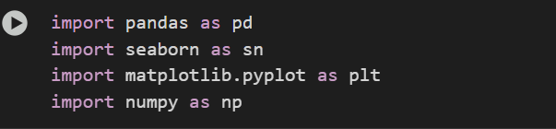

Information : This is the library that I used for doing this project among others Pandas, Seaborn. Matplotlib, Numpy etc.

1. Import Csv

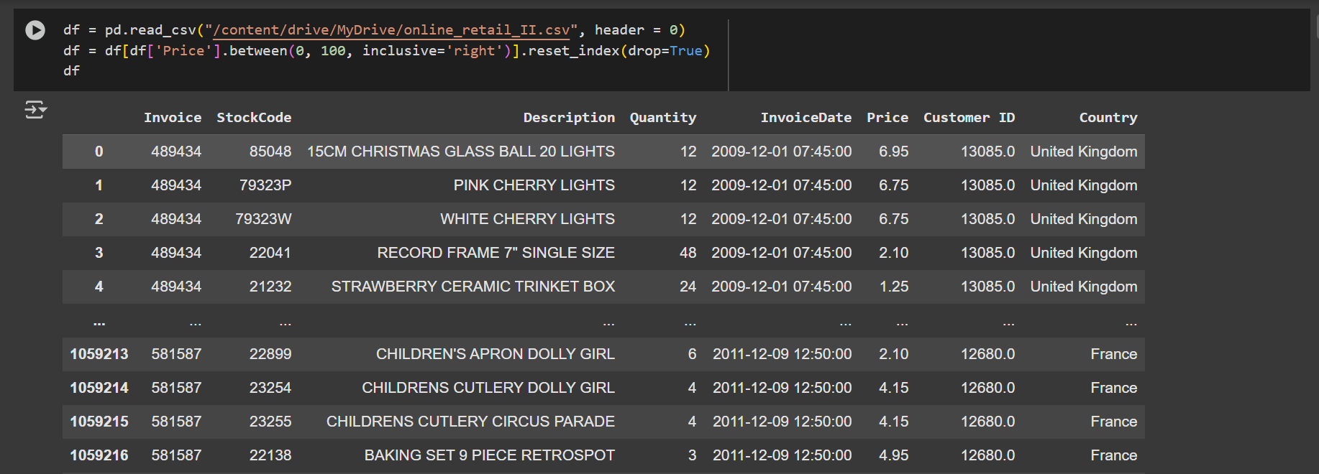

Information :

* *df* is an early variable that I used for the first time, and I am using the pandas to read csv, and *header* the means of the first row from a file that I use as column name.
* Row of number 2 is a get a row where value in the columns price is in the range 0 until 100
* Reset index means reset DataFrame Index and *Drop True* never save past index as column

1. Create Binning Data

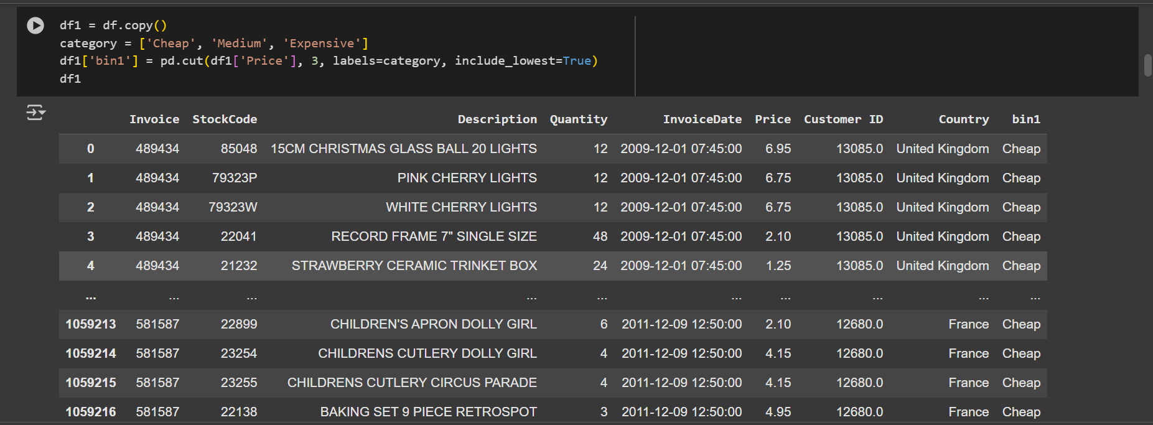

Information :

* ***df1*** Create copy from dataFrame and saving to new variable, the purpose is originally data was never change while doing process
* This is a definition list labels from price category (“Cheap”, “Medium”, “Expensive”) that used for grouping price process last
* ***pd.cut*** function is used for dividing the price column into 3 groups.
* *df[‘price’]* = column that want grouping
* *3* = Grouping amount that want
* *labels=category :* Giving category name for each bin (“Cheap”, “Medium”, “Expensive”)
* *Include_lowest*  = Ensure low value entered into first category
* The result from this code is a Cheap for low price, Medium for middle price, and Expensive for high price

binning1_Summary

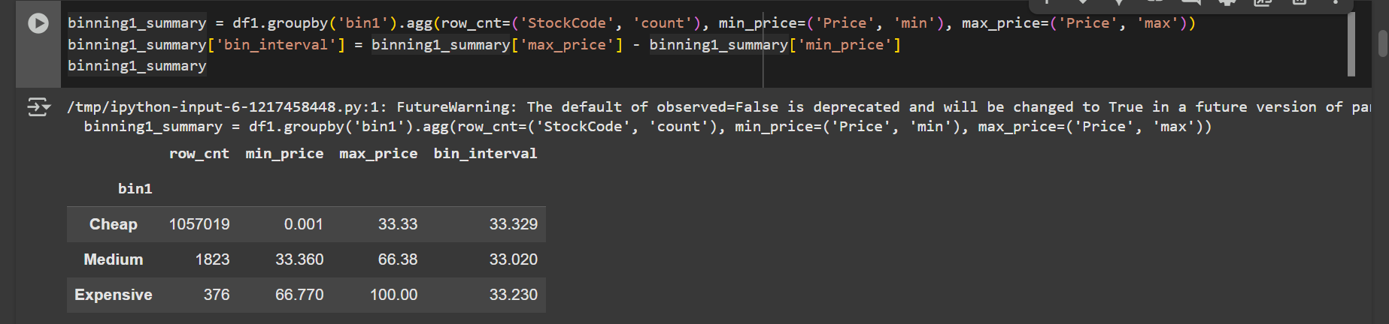

Information :

* *df1.groupby(‘bin1’)* : grouping data base price category (‘Cheap’,’Medium’, ‘Expensive’) and running function aggregation *(agg)* for each group.
* The function of aggregation *(agg)*

1. ***row_cnt=(‘StockCode’, ‘count’)*** : Amount the number row (product) each category Price
2. ***min_price=(‘Min’, ‘Price’)*** : Get of the low price into category
3. ***max_category=(‘max’, ’Price’)*** : Get of the highest price into category

* Adding a new column that shows the price range in every category. The amount from *max_price* - *min_price.* The means is a much wide price into each bin ora category
* The result is a client can know about the amount of product distribution for each price category, price range in every bin category, how evenly divided part of the bin result from before *pd.cut.*

Binning product price with line space

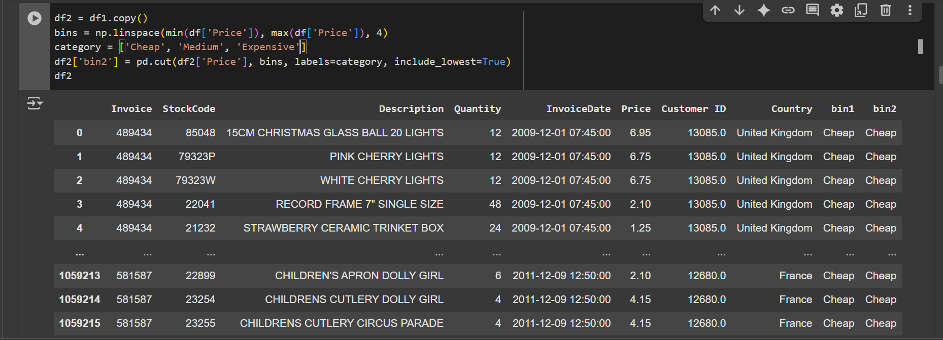

Information :

* *df2 =* Create DataFrame copy *df1* become *df2*
* In this case using linespace, linespace is another method that is used for making bins, or another nickname is to make manual bins.
* Same as above but in this code using *np.linespace.* Create 3 interval that is divided rate from low value to highest value using *linespace*
* Same as above in this code there are definition label name to every bin (‘Cheap’, ‘Medium’, ‘Expensive’)
* Create a new column [‘bins’] that categorizes price into bins, based on bins that are decided according to the manual.

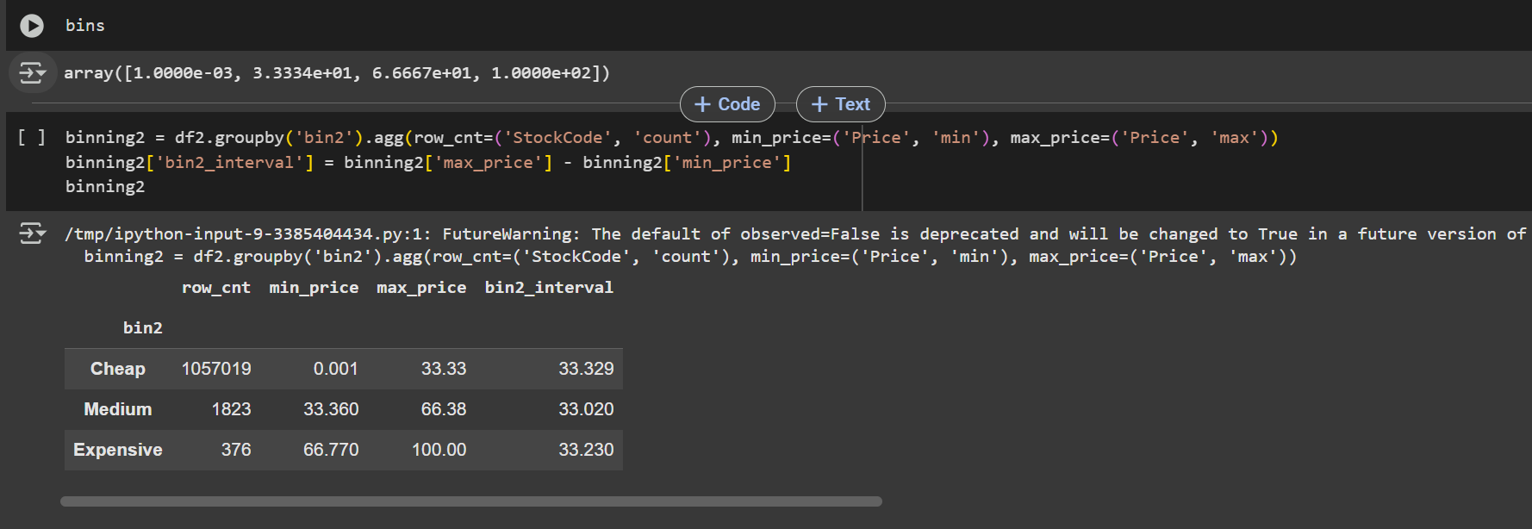

Information:

* Divided Price into 4 type: Cheap, Medium, Expensive
* Grouping Date base on price category ( Row_cnt, min_price, max_price, and bin_interval)

1. Binning with a length for each interval

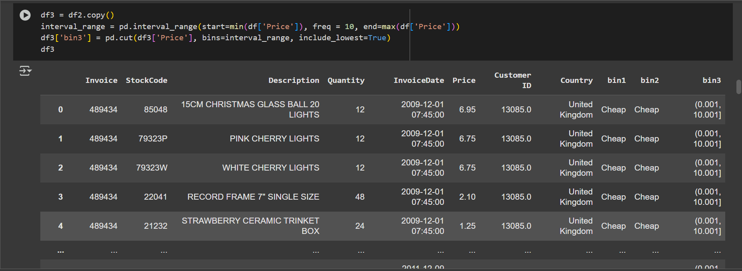

Information:

* The purpose of this code is a divided price value into main interval
* Interval_range is a create main interval starting from minimum price until maximum price
* The mean of the *freq=10* is a every bin have width 10 each price
* Df_3[‘bin3’] grouping price value into bin that is create
* The means of *include_lowest* is a make sure that minimum price also sign in into early interval

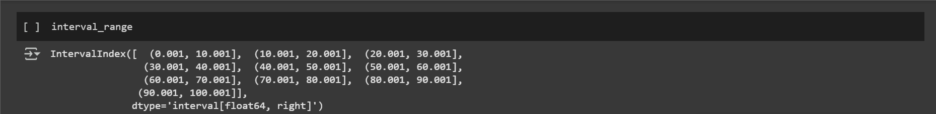

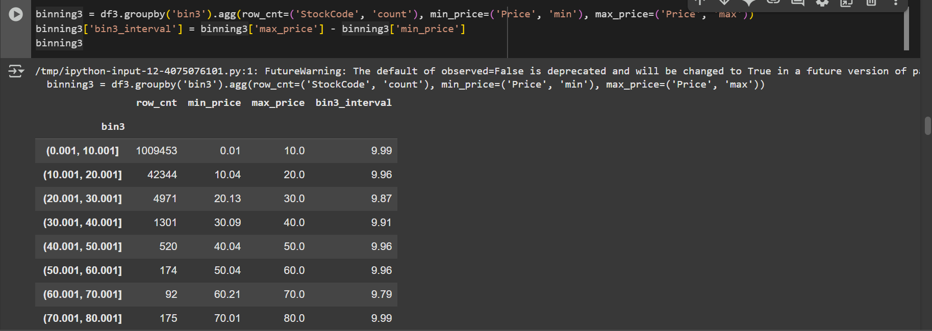

Information :

* Analyzes spread of price data base on binning (*bin3)*
* Grouping base on binning 3 (interval price )
* Calculate the amount (product), (minimum_price), (maximum price each interval)
* Amount the price range each bins
* Binning3 = df.groupby(agg3).agg grouping base on *bin3,*  main price interval and agg tha use as aggregation for every group *row_cnt, min_price, max_price*

1. Binning with a length for each bins that set by own need

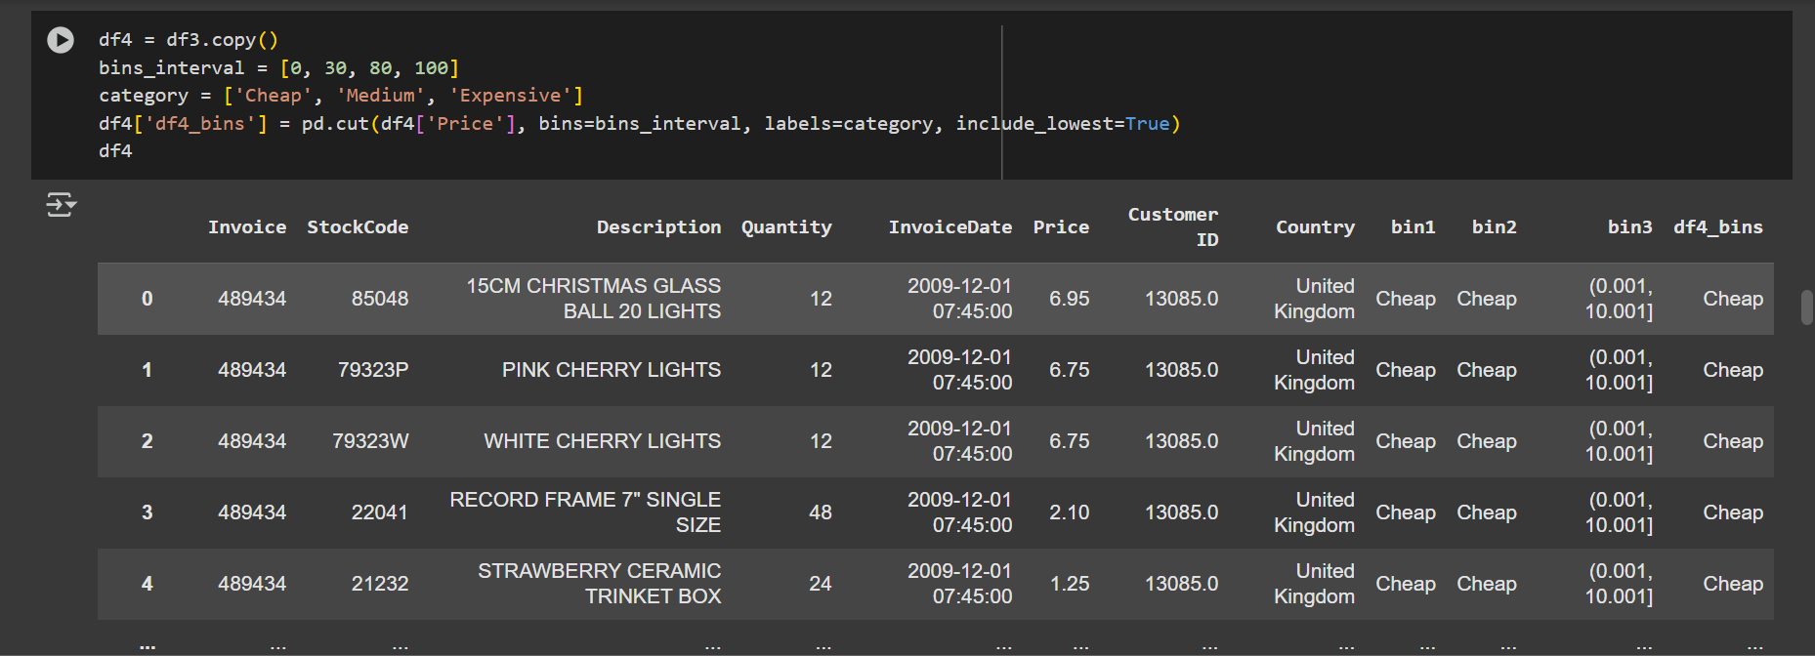

Information :

* Create bins_interval that group the price. Probably that (0, 30, 80, 100)
* Adding categories that represent the range of 0, 30, 80, 100. 0-30 it’s Cheap, 30-80 it’s Medium, 80-100 it’s Expensive
* The function of the ***pd.cut*** divided numeric value into bin category base on price value

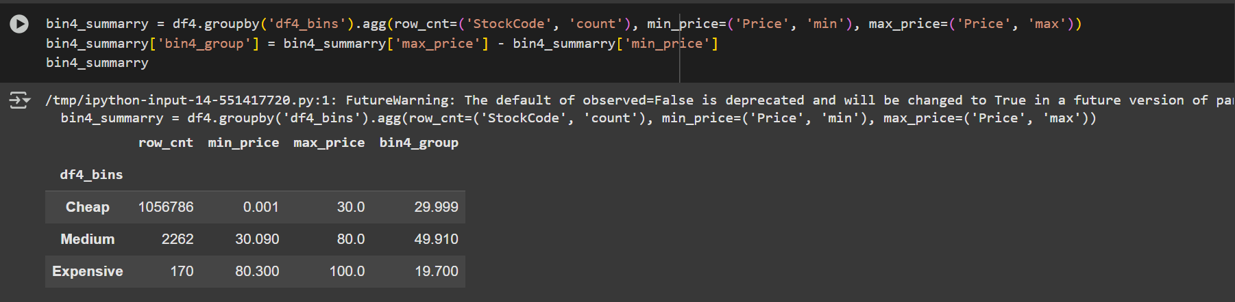

Information :

* Analyze and serving simple statistic for price category
* *Df4.groupby*  is grouping date base on price categories column that in previously create
* *.agg calculate statistic/aggregate* for every categories *row_cnt, min_price, max_price*
* *Bin_summary[‘bin4_group’] =* adding new column that amount difference among *max_price* and *min_price*
* This code is so important because set price strategy, discount, product segmentation

1. Binning with a lot by certain bins and a lot member any same bins

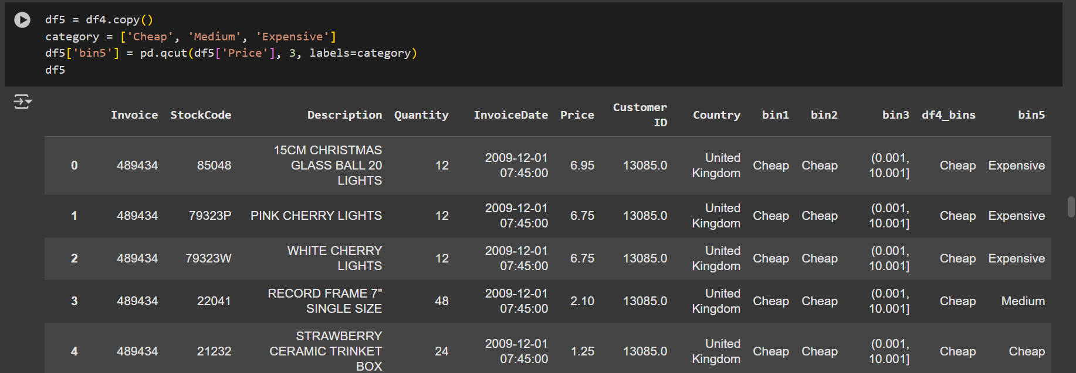

Information :

* Grouping category on csv and base on Cheap, Medium, Expensive
* The function of the *pd.cut* is a divided numeric value into bin_category

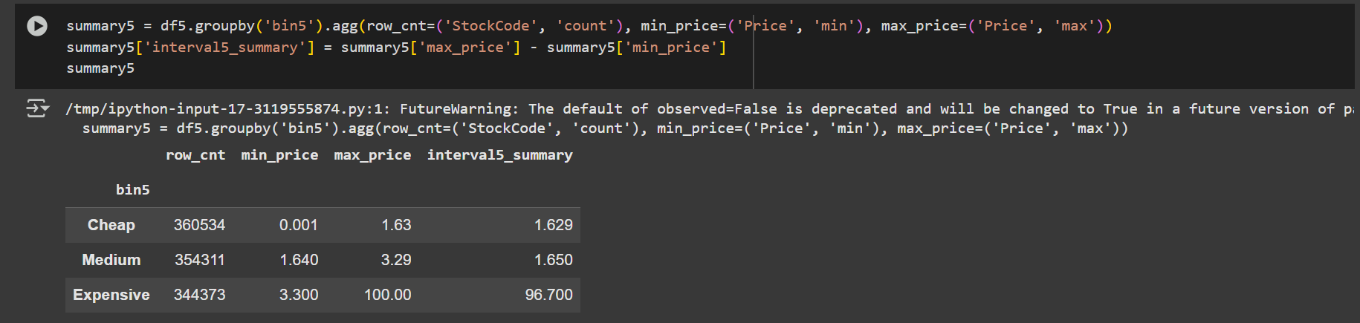

Information :

* Create statistic summary from df5 which have been divide into group (bin) base on column bin5
* Knowing calculate data, price minimum and price maximum into every bins
* Calculate of the distribution width actual price
* df5.groupby(‘bin5’) is a grouping data base on column bin5 , that the fill usually binning result of the price
* .agg get important statistic from every group *row_cnt, min_cnt, max_cnt*
* Summary5 = knowing distribution width actual price into own bin
* Is so useful for evaluation price variation price between product in to won bins

1. Seeing item that there are in description column

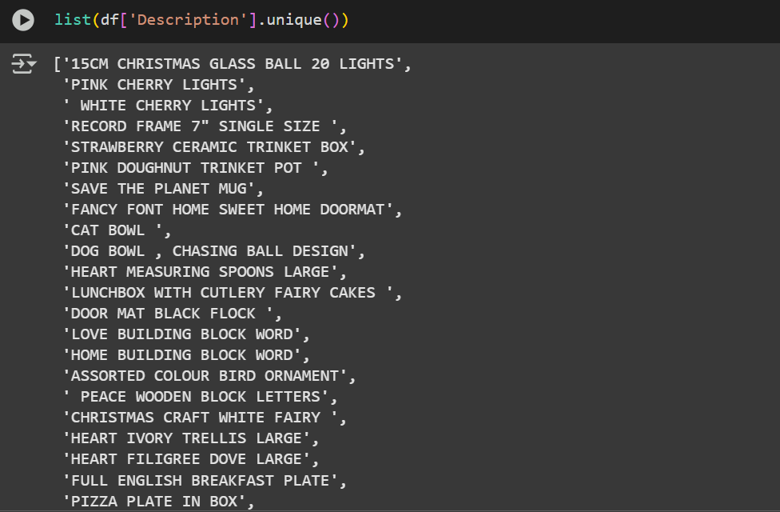

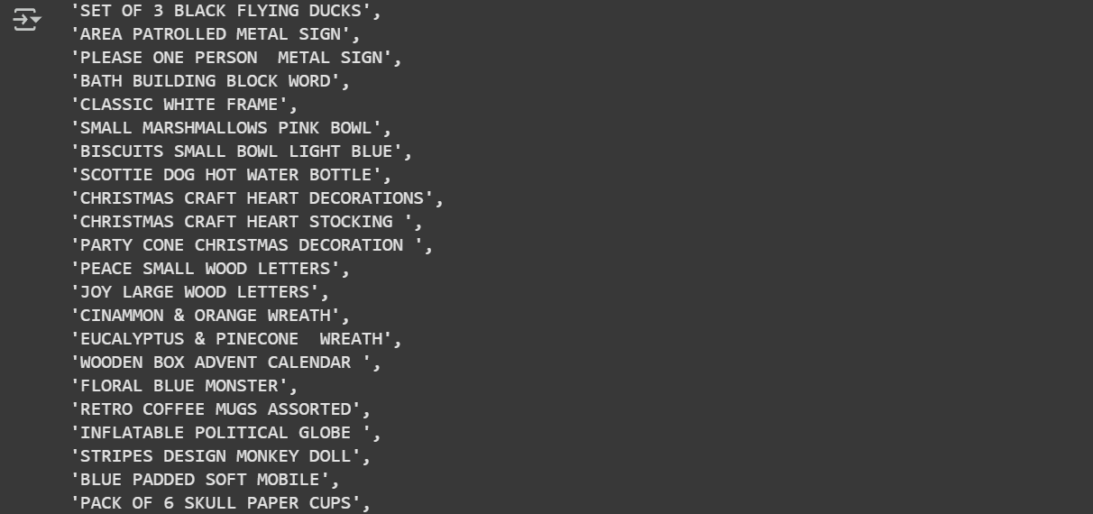

Information :

* This is code that showing name product on description product

1. Grouping with case statement

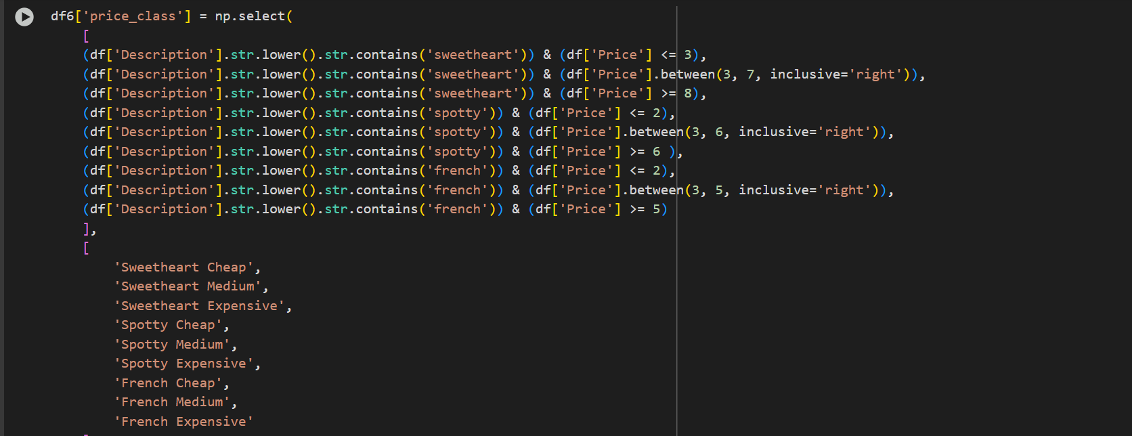

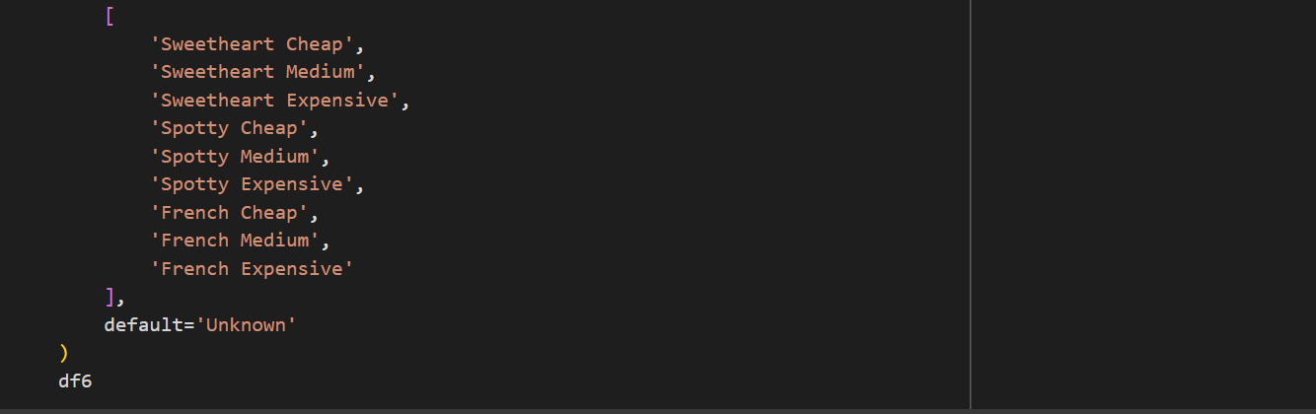

Information :

* *Np.select* is the function that use apply mmilti-condition on column
* *(df['Description'].str.lower().str.contains('sweetheart')) & (df['Price'] <= 3) → 'Sweetheart Cheap'*  condition for name from description. Example ‘sweetheart’
* There are value in code that refer of the price on every name write in code and the meaning number in the behind is refers from prise that adjust
* This code can using to price labels
* Can also visualisation

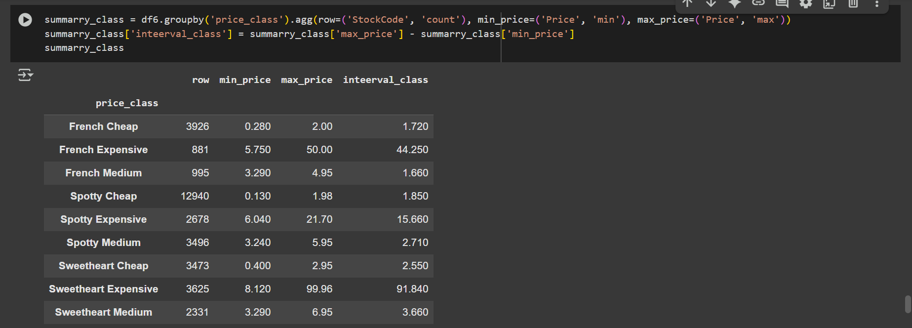

Information:

* Create summary statistics for every price_class. *Row, min_price, max_price, interval_class*
* Create part of product that client or personal that they want product to analysis base min_price, max_price, interval_class
* In this code a summary from part of the product that client wants analysis and depending client require name product that they want.

1. Exploratory Data Analysis
2. Import Library

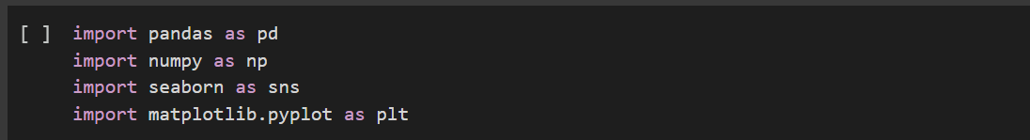

Information : Begin information about library that use in this project

1. Import Csv

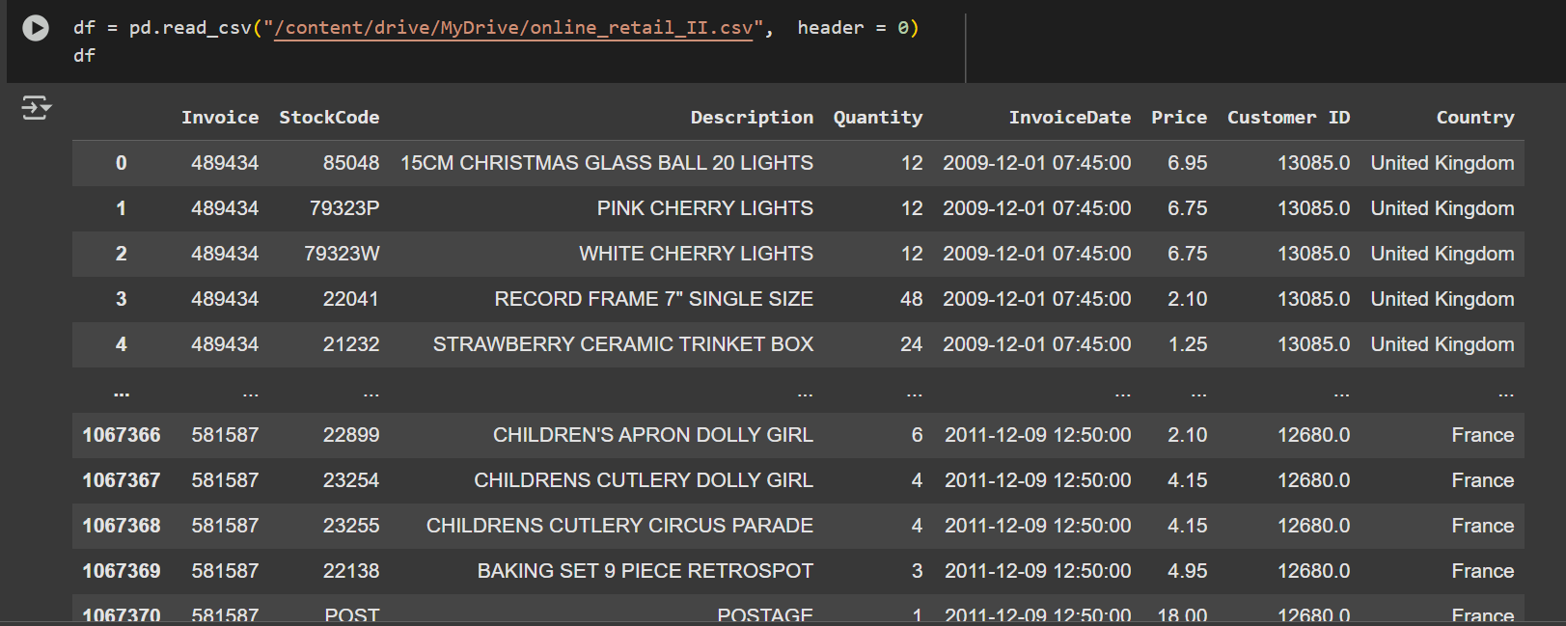

Information :

* Import Data from CSV
* *df* is a presented about calling CSV and using *pd.read_csv*

1. Data Cleaning

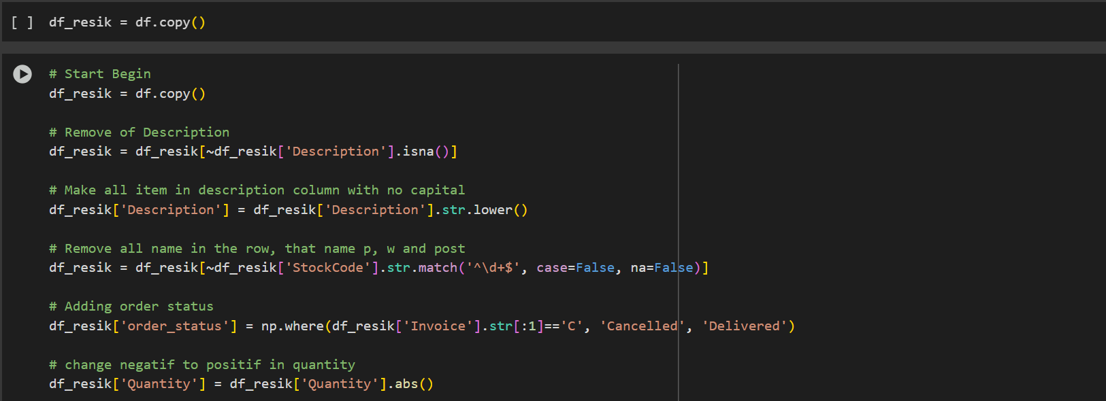

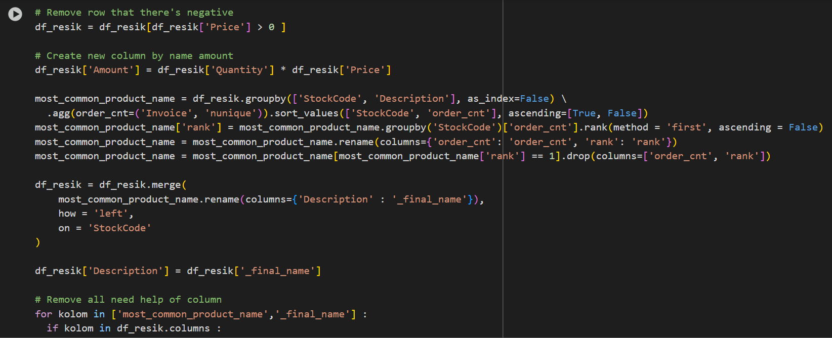

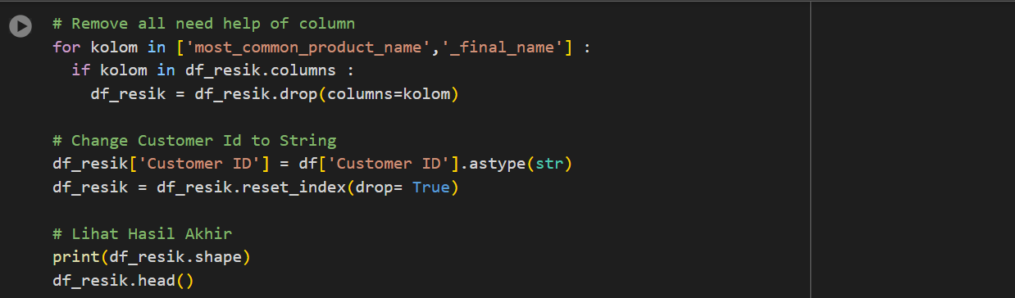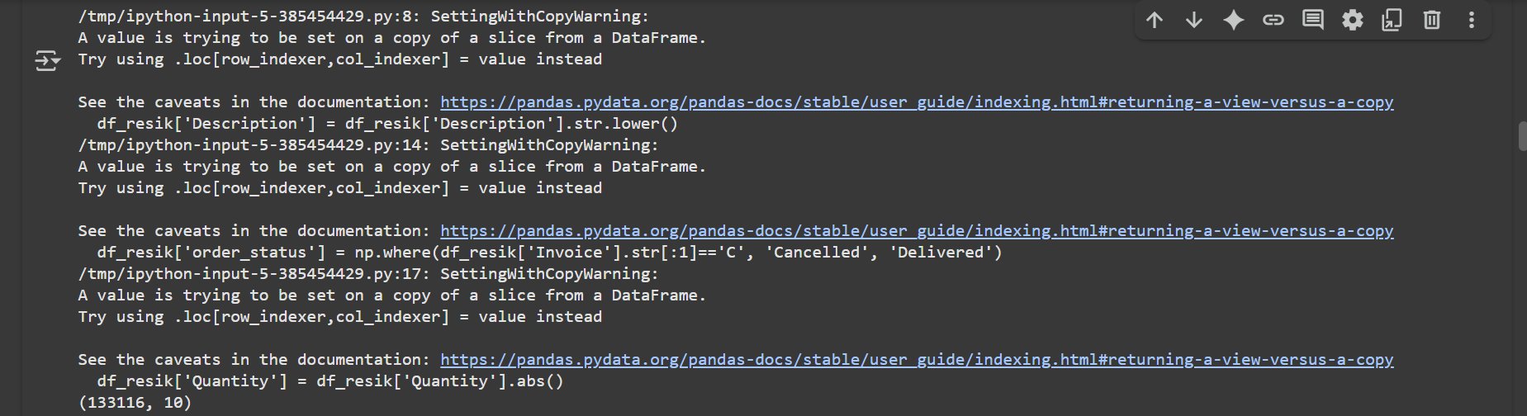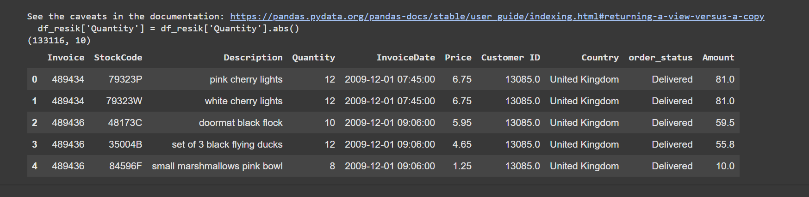

Information :

* Removing row the description columns null
* Changing all teks in description columns to small abjad so consistent
* In the code df_resik = df_resik[~df_resik[‘stock_code]] remove the row with that only number. Usually special code, and when in the row hasn't (P, W, Post) this is not relevant
* Create order status column
* *df_resik*[‘Quantity’] = df_resik[‘quantity’].abs() in this code change negatif to positif
* *df_resik = df_resik[df_resik[‘price’] > 0] removing row with negative price*
* Create column amount mean amount from Amount * Price
* most_common_product_name can the mean grouping data base stockCode and Description, amounting unique order, ranking each description into StockCode base order amounting more a lot, saving only original name product is so commonly for each item every StockCode

1. EDA (Exploratory Data Analysis )
2. Knowing about amounting row and columns

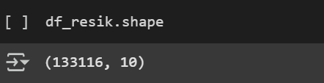

Information : this function code is a check about amounting row and column from own project

1. Info type data for each column and row

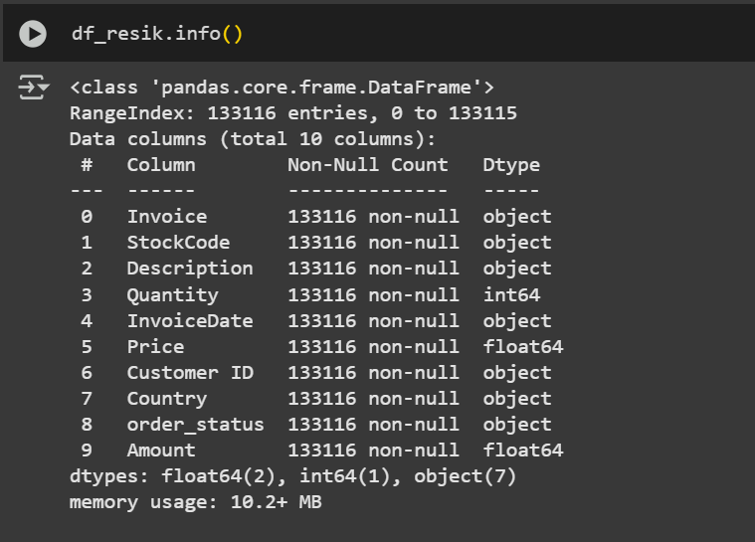

Information : Checking all type data from your csv project that is important to continue the step act.

1. Knowing unique value of categorical columns and variable

* Unique value

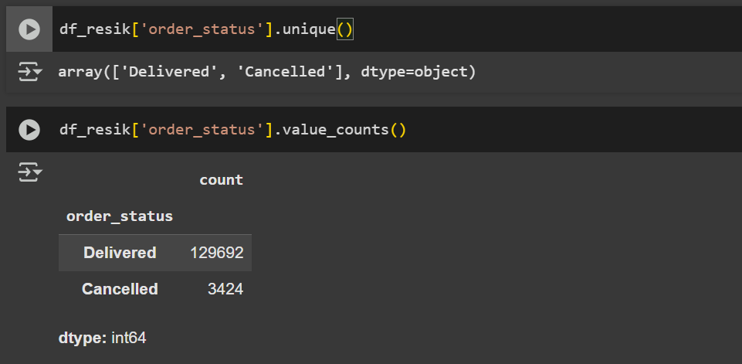

Information : Looking unique value from columns order-status

* Amounting all from Delivered and Cancelled



Information : Amounting number delivered and Cancelled from order_status columns

1. Descriptive count statistic from DataFrame

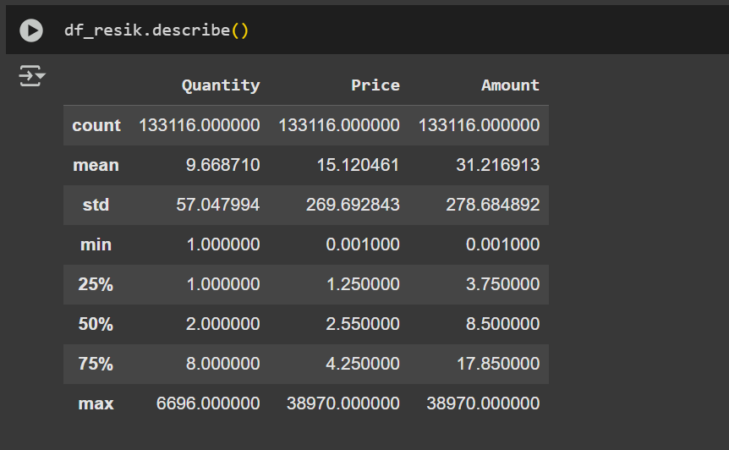

Information : This code is a statistic amounting like mean, std, quartile 1, quartile 2, quartile 3, max, and min.

1. Knowing statistic every herself

* No null value

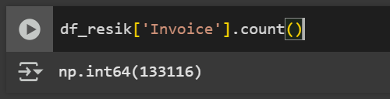

* Unique frequency

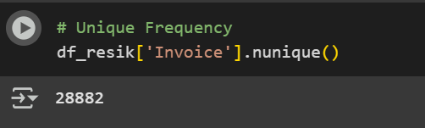

* Sum from quantity

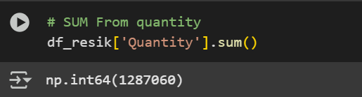

* Subset (SUM) from subset

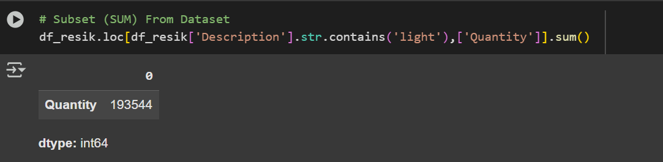

Information : Checking in the description column are contain the sentence “light” and amounting all value from Description column

* Mean from quantity

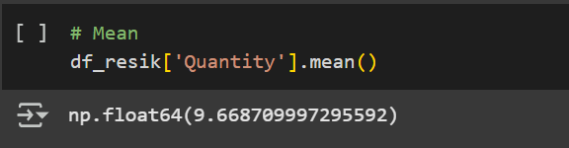

* Subset (MEAN) from subset

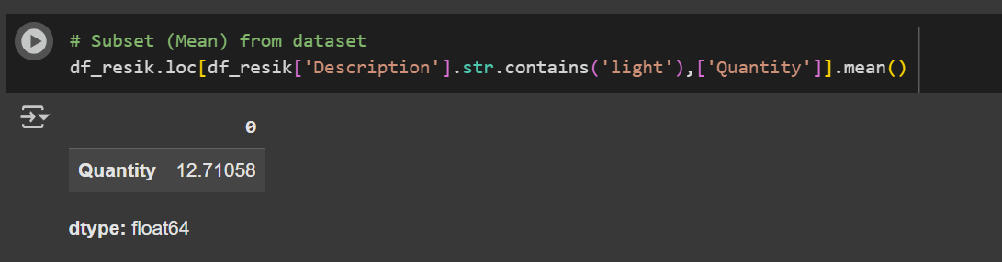

Information : Checking in the description column are contain the sentence “light” and amounting mean value from Description column

* Median

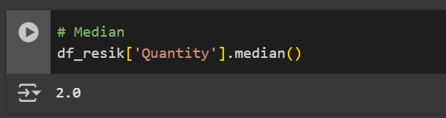

* Subset (MEDIAN) from subset

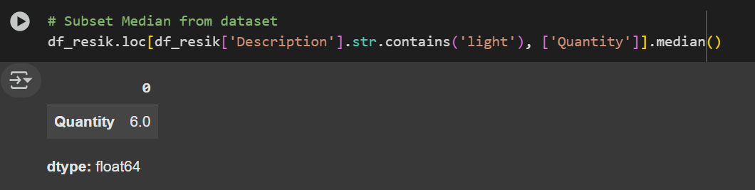

Information : Checking in the description column are contain the sentence “light” and amounting Median value from Description column

* Mode

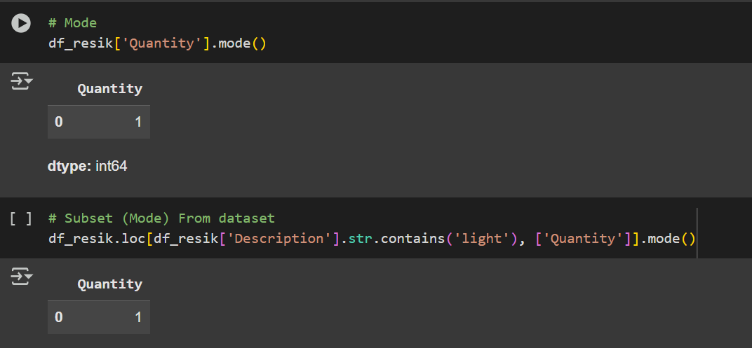

* Subset (MODE) from subset



Information : Checking in the description column are contain the sentence “light” and amounting Mode value from Description column

* Range

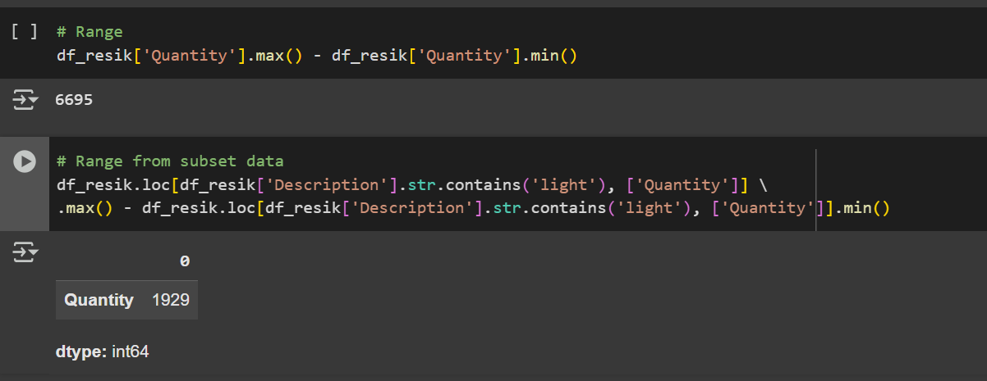

* Range from subset data



Information : This code is used to calculate the range of the `Quantity` values for products whose descriptions contain the word “light”. The calculation is done by taking the maximum (`max()`) value of `Quantity` from that subset and subtracting the minimum (`min()`) value. The result represents the variation or difference between the highest and lowest quantities of products sold within this group. In other words, the range provides an overview of how widely distributed the sales quantities are for products associated with the keyword “light”

* Std

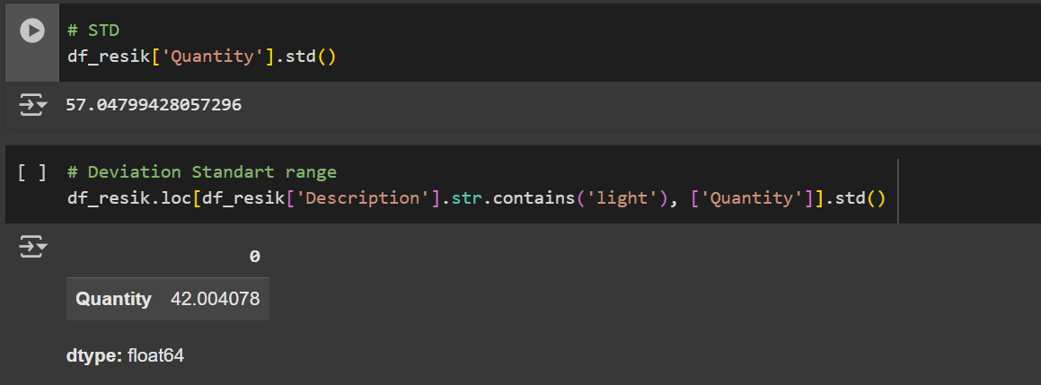

* Deviation Standard Range



Information : Checking in the description column are contain the sentence “light” and amounting Deviation Standard range value from Description column

* Variance

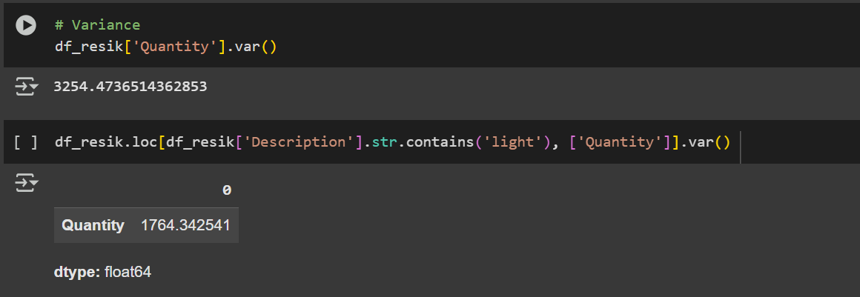

* Variance from subset data



Information : Checking in the description column are contain the sentence “light” and amounting Variance value from Description column

* Quantile

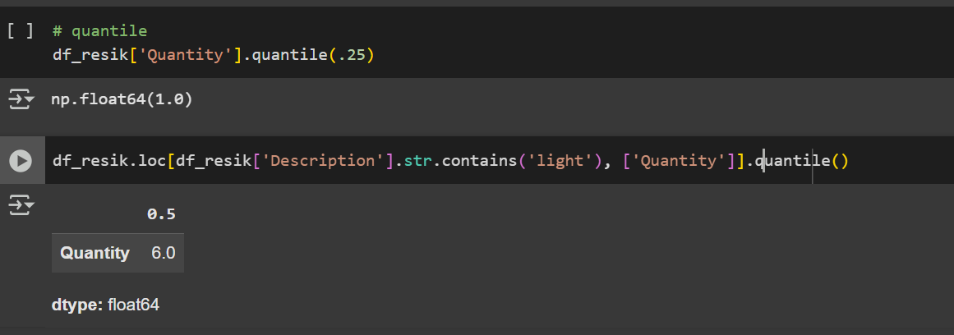

* Quantile from subset data



Information : Checking in the description column are contain the sentence “light” and amounting Quantile (Q1) value from Description column

* Range interquartile from subset data

1. Count Statistic by grouping

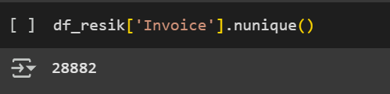

1. Aggregate only one column

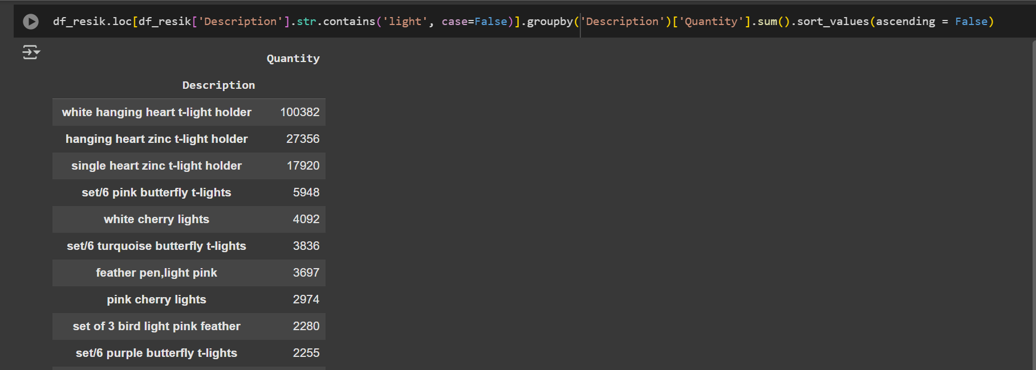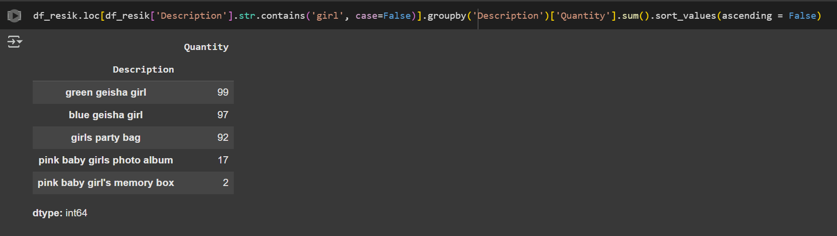

1. Aggregate few columns

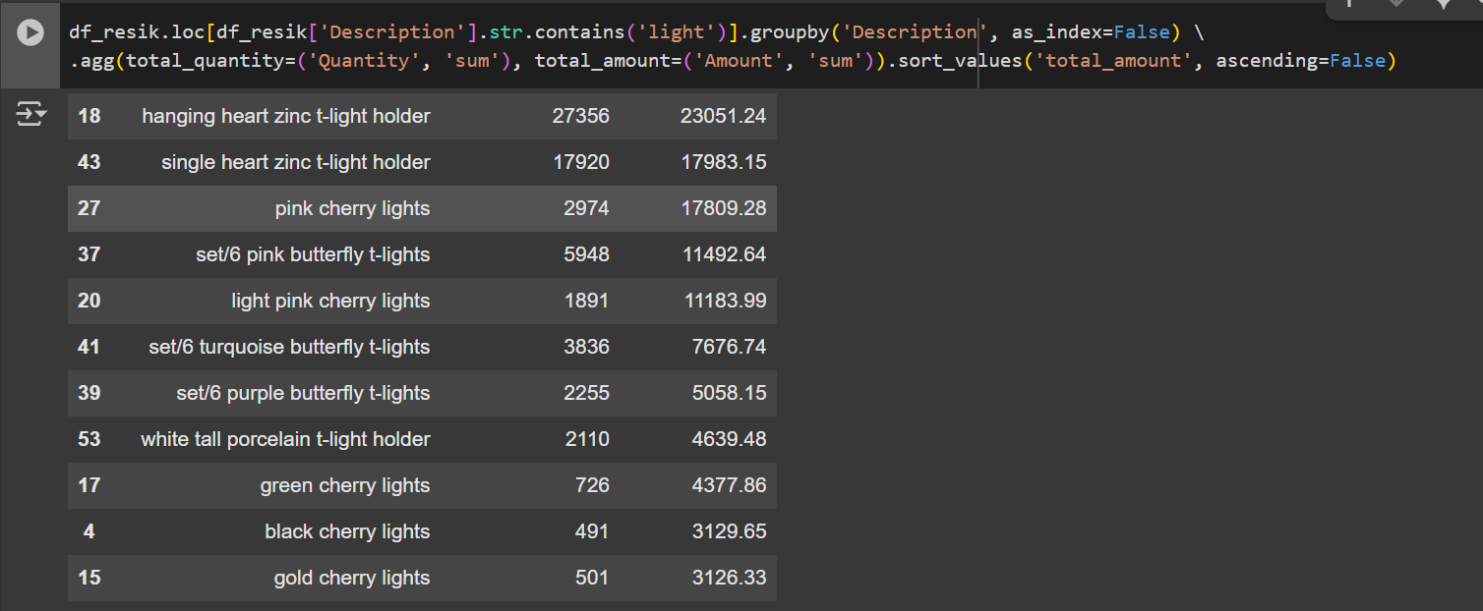

1. Data Visualization and Correlation
2. Import Library

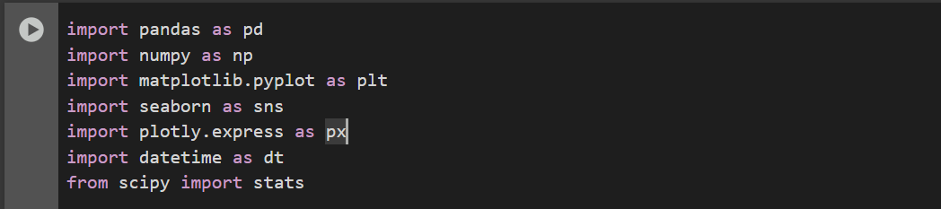

Information : Begin information about library that use in this project

1. Import CSV

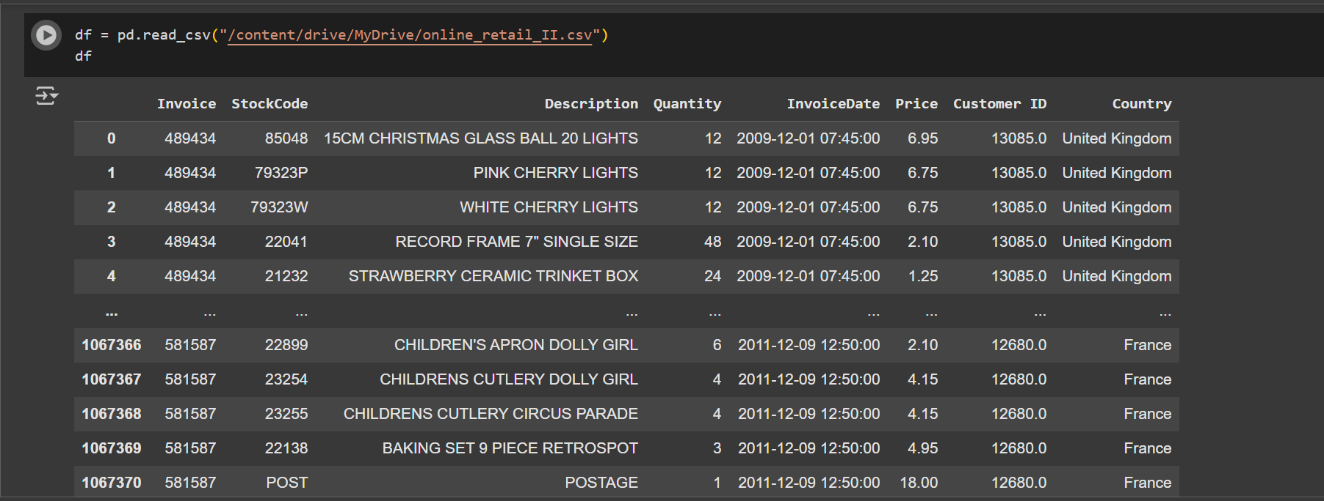

Information : This code using to read data from CSV

1. Data Cleaning

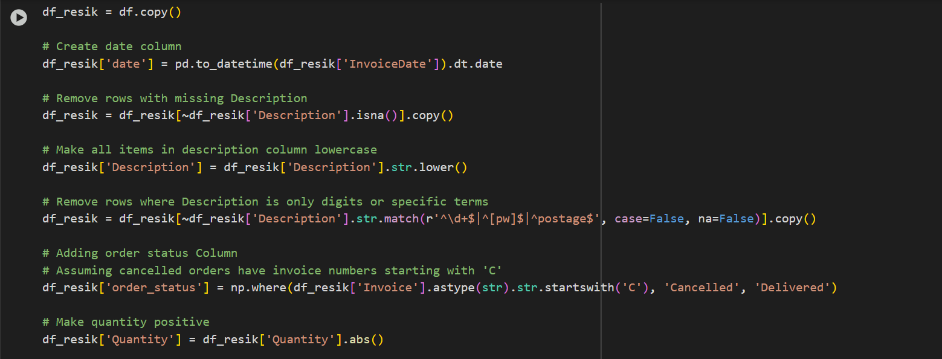

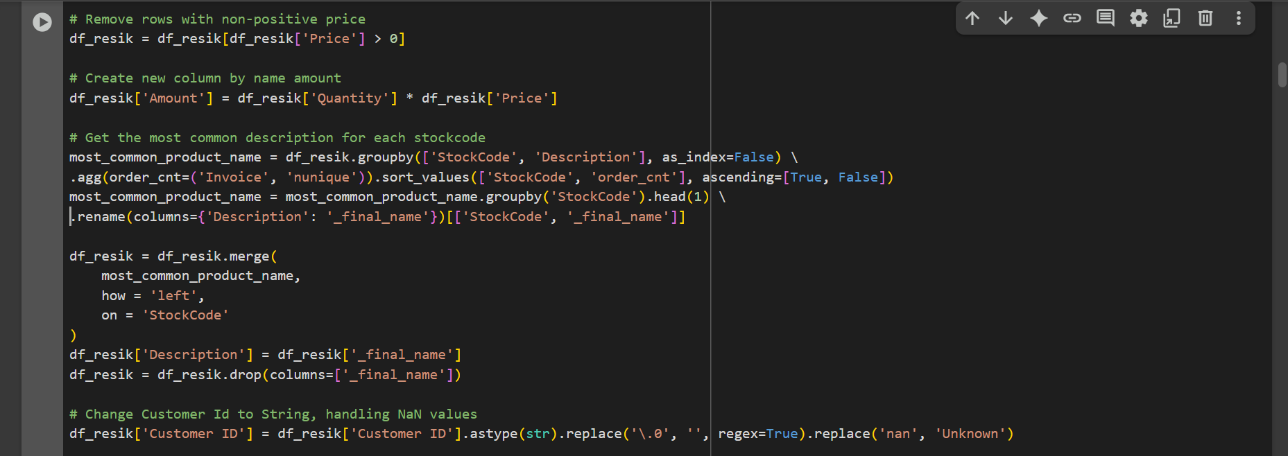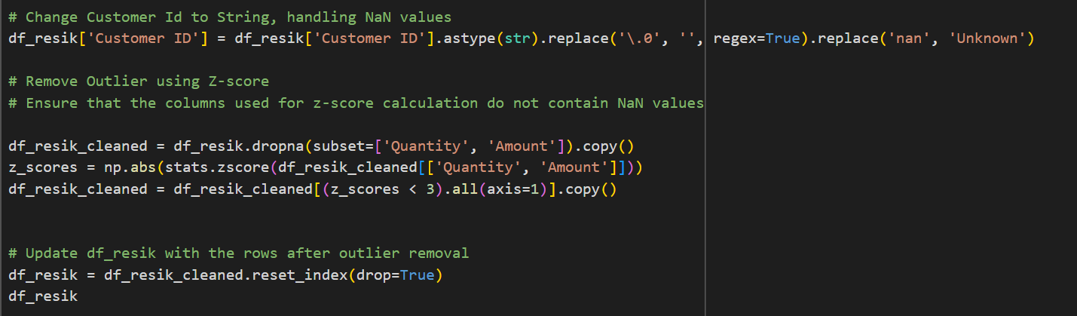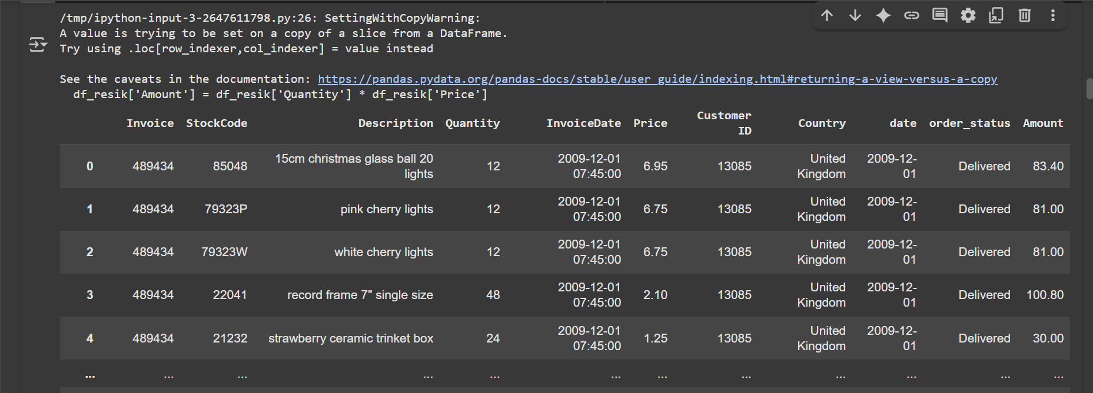

Information :

* df_resik = df.copy() Make a copy of the original DataFrame df into df_resik to avoid modifying the original data directly.
* df_resik['date'] Converts the InvoiceDate column into a proper datetime format. Extracts only the date part (ignoring the time).
* df_resik[~df_resik['Description'].isna()].copy() Drops rows where Description is null/NaN, ensuring all products have valid descriptions.
* df_resik['Description'] Converts all product descriptions to lowercase for consistency and easier text processing.
* df_resik[~df_resik['Description'] ] Drops rows where the description is, Only digits (e.g., "12345").A single letter p or w. the word postage. This step cleans the dataset from irrelevant or non-product entries
* df_resik['order_status'] Create new columns order_status. If the invoice number starts with "C", the order is Cancelled; otherwise, it is Delivered.
* df_resik['Quantity'] Converts all quantities to positive values, since negative numbers often represent returns or errors.
* df_resik[df_resik['Price'] > 0] Keeps only rows where the price is positive. Ensures that free or invalid transactions are excluded. Df_resik[df_resik[‘price’] > 0]
* df_resik['Amount'] Adds a new column Amount = total sales value per row (quantity × price).
* Most_common_product_name Groups data by StockCode and Description, counting how many unique invoices each description appears in (order_cnt). Sorts so the most frequent description per stock code is ranked first. For each StockCode, selects only the top 1 description as the **final standard name**.
* df_resik.merge is a Merge of the cleaned dataset with the most common product names and Updates the Description column so that all rows of the same StockCode share the most frequent name. Removes the helper column _final_name.
* df_resik['Customer ID'] Converts Customer ID to string type. Removes trailing .0 (caused by float-to-int conversion). Replaces missing values (nan) with "Unknown".
* df_resik_cleaned Drops rows with missing values in Quantity or Amount. Calculates Z-scores (standardized scores) for Quantity and Amount. Keeps only rows with Z-score < 3 (within 3 standard deviations), effectively removing extreme outliers.
* df_resik = df_resik_cleaned.reset_index(drop=True) Replaces the dataset with the cleaned version (after outlier removal). Resets index to keep it tidy Returns the cleaned DataFrame.

1. Data info in the every columns (type data)

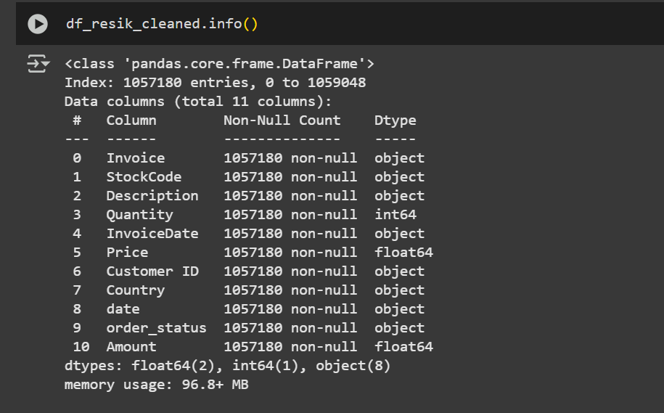

Information : This code fill the information type data from every column

1. Data Visualisation

* Pivot Table

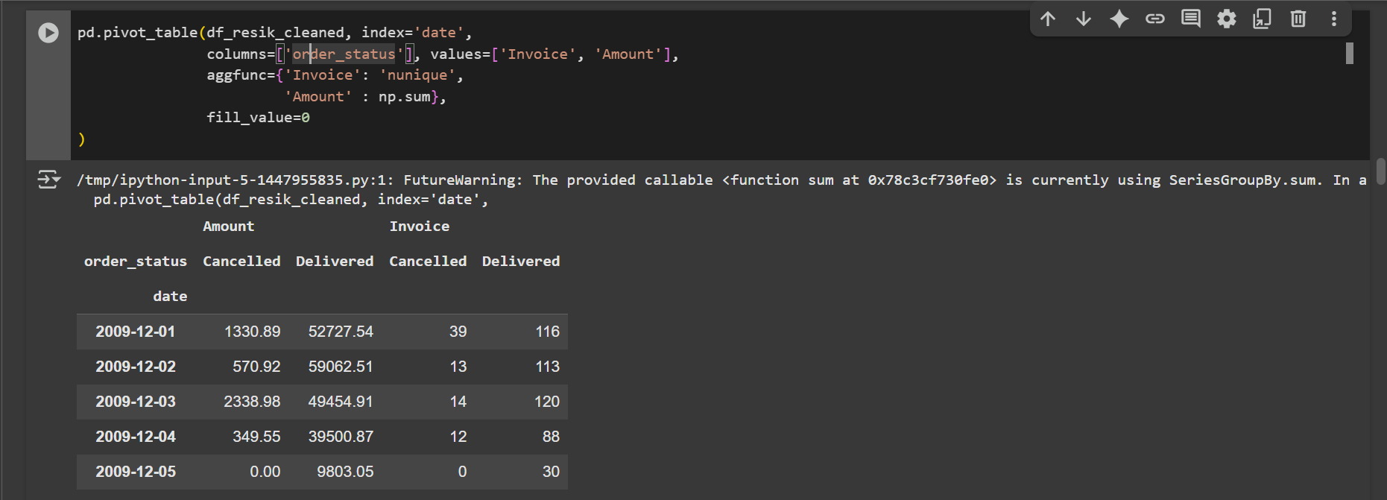



Information :

1. Index = ‘date’ Rows are grouped by **date** (the transaction date you created earlier)
2. Columns = ‘order_status’ Columns are divided into two groups: "Delivered" and "Cancelled" orders.
3. Values = [‘Invoice’, ‘Amount’] we are analyzing two metrics. Invoice → number of unique invoices. Amount → total transaction amount.
4. aggfunc={'Invoice': 'nunique', 'Amount': np.sum} For Invoice: calculates the **number of unique invoices** per date + status. For Amount: calculates the **sum of transaction values** per date + status.
5. fill_value=0 Ensures that if a date/status combination has no value, it shows 0 instead of NaN

* Bar Chart (Vertical)

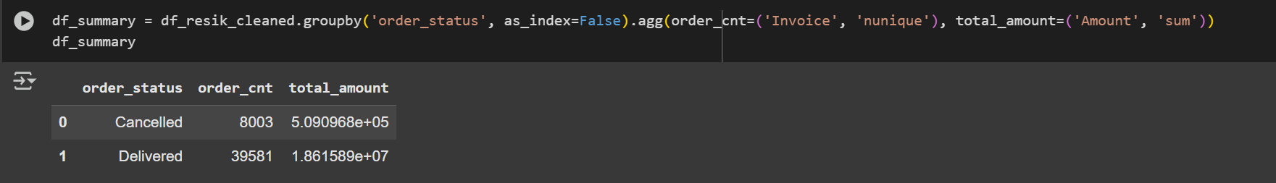

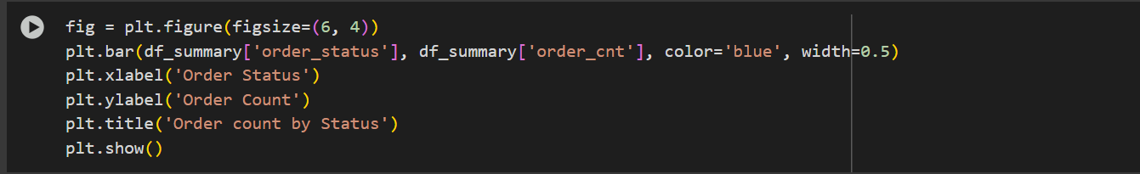

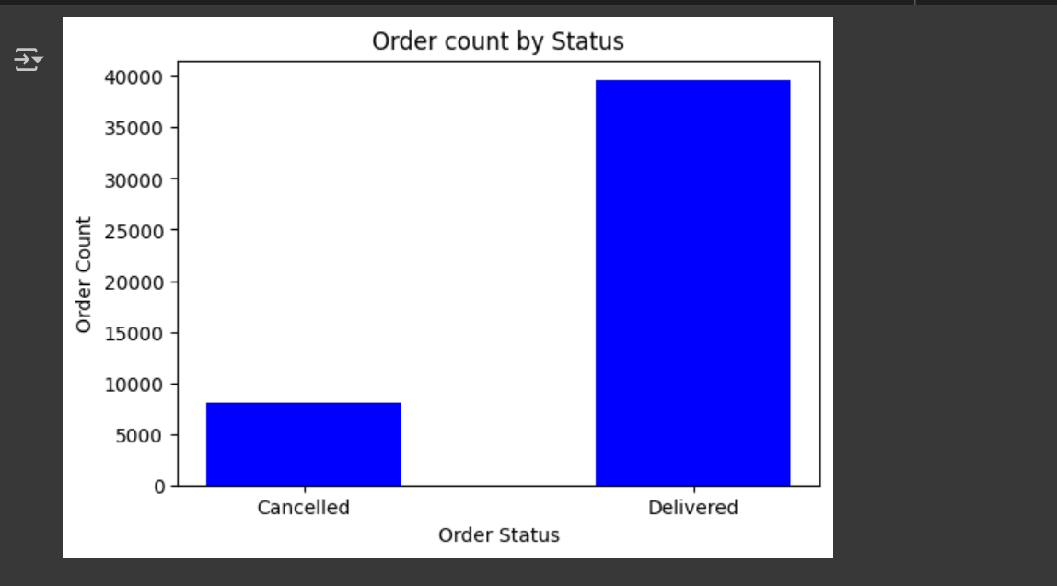

Information :

1. df_summary This code **groups the cleaned dataset by order status** (Cancelled vs Delivered). The result is a summary table showing the scale of cancelled vs delivered orders, both in **count** and **revenue**.

It compute :

1.1 order_cnt: how many **unique invoices** exist in each status.

1.2 total_amount: the **sum of transaction amounts** in each status

1. This code **takes the summary table (df_summary)** and visualizes one metric: order_cnt.
2. It creates a **bar chart** comparing the number of cancelled vs delivered orders
3. X-axis = order_status, Y-axis = order_cnt.
4. Helps you see at a glance that delivered orders far exceed cancelled ones.

* Bar Chart (Horizontal)

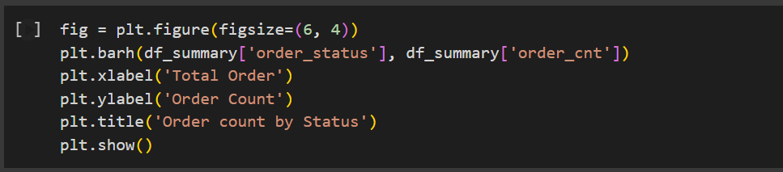

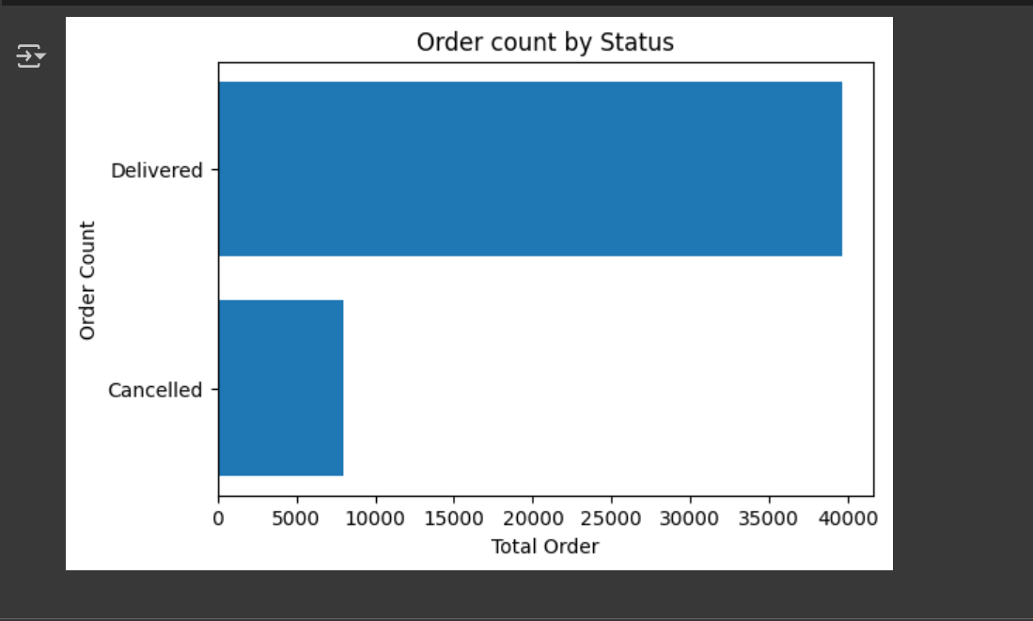

Information :

1. **plt.barh**: draws horizontal bars instead of vertical ones
2. **X-axis**: now represents the **total number of orders**.
3. **Y-axis**: represents categories (Cancelled vs Delivered).
4. A horizontal comparison where the longer bar indicates higher order_cnt.

* Histogram

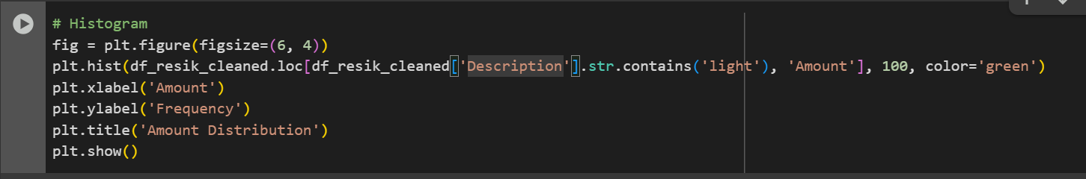

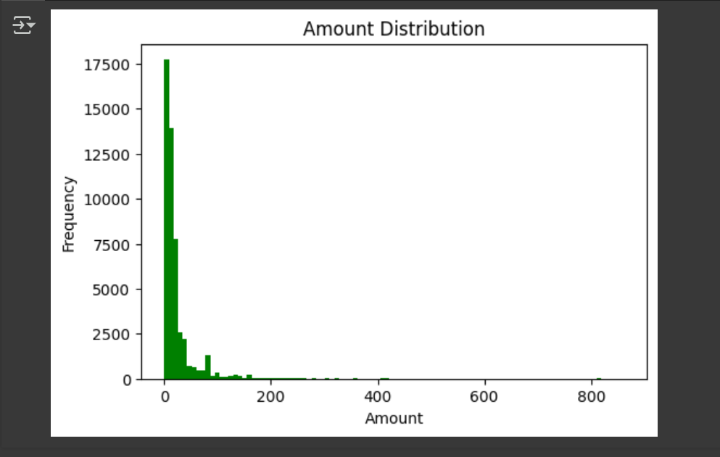

Information :

1. df_resik_cleaned.loc[df_resik_cleaned['Description'].str.contains('light') Filters rows where the product description contains "light", then selects their transaction Amount.
2. plt.hist(..., 100, ...) Builds a histogram with **100 bins** (intervals). Each bar’s height = how many transactions fall into that amount range.
3. **X-axis** (Amount): ranges of transaction values.
4. **Y-axis** (Frequency): number of transactions in each range.

Visualisation goal Helps you see if the transaction amounts for "light" products are

4.1 Mostly small purchases

4.2 Or skewed with a few very high-value transactions.

4.3 Spread out evenly

* Pie Chart

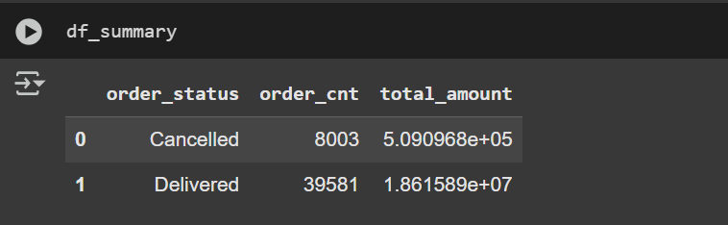

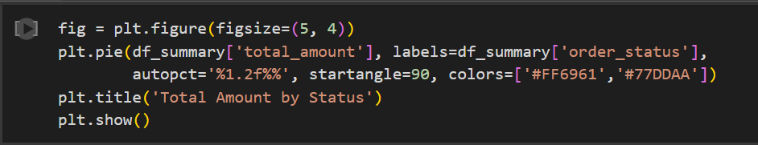

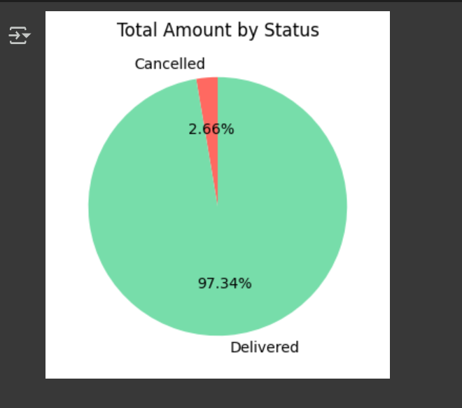

Information :

1. df_summary This code **groups the cleaned dataset by order status** (Cancelled vs Delivered).
2. plt.pie(...)

2.1 **df_summary['total_amount']** → values for each slice of the pie (the size of each sector)

2.2 **labels=df_summary['order_status']** → the labels for each slice (e.g. *Delivered*, *Cancelled*).

2.3 **autopct='%1.2f%%'** → displays the percentage on each slice. %1.2f means 2 decimal places (e.g. 97.34%)

2.4 **startangle=90** → rotates the pie chart so it starts from the top (90°).

1. plt.show()

* Line Chart

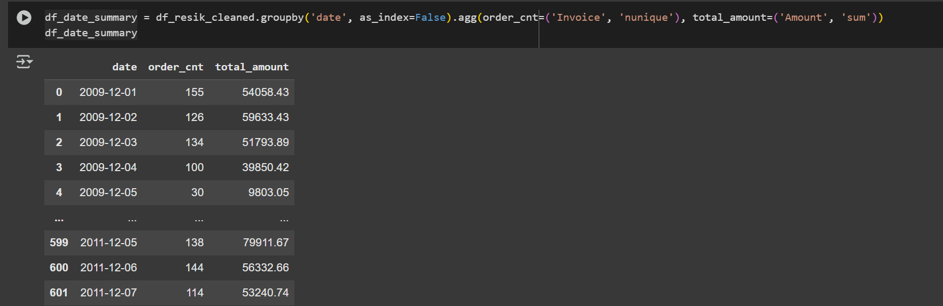

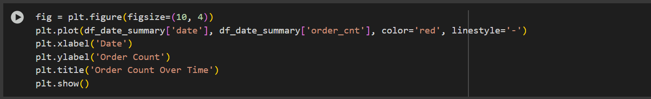

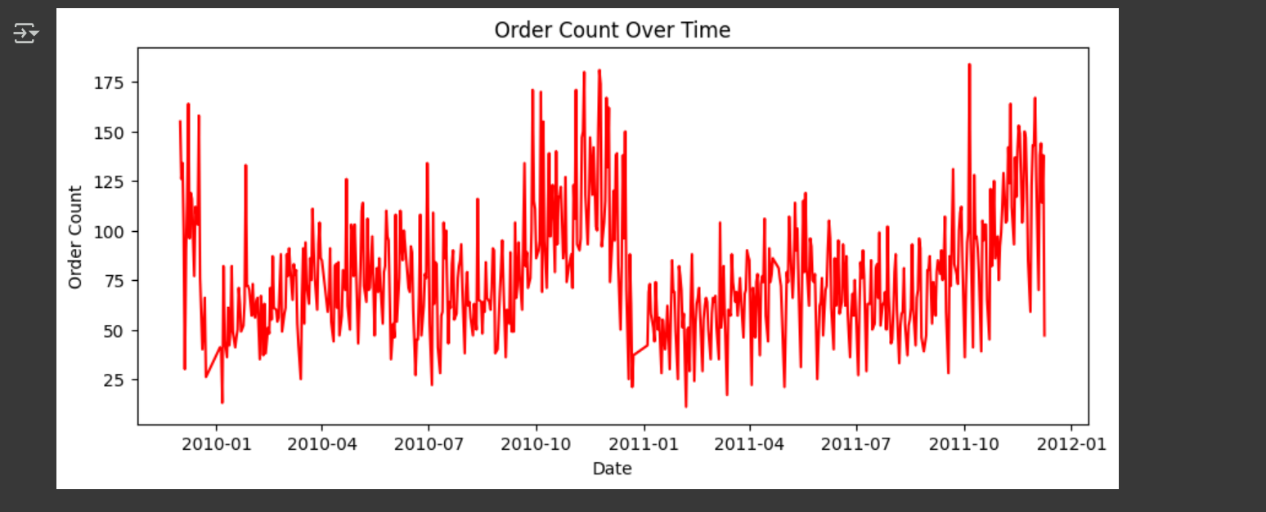

Information :

1. groupby('date', as_index=False) Groups the dataset by the date column (the transaction date you created earlier). as_index=False keeps date as a normal column instead of turning it into an index.
2. .agg(....) order_cnt=('Invoice', 'nunique')counts how many **unique invoices** occurred on each date. total_amount=('Amount', 'sum') sums up all transaction values (Amount) on that date
3. **X-axis** = timeline of transactions (from 2010-2011 in your dataset).
4. **Y-axis** = daily number of orders (order_cnt).
5. **Red line** = shows how order volume changes over time.  
   You can immediately spot:

5.1 Peaks → days with unusually high orders.

5.2 Dips → days with few or no orders.

5.3 Seasonal or periodic trends (e.g., spikes near holidays).

* Scatter Plot

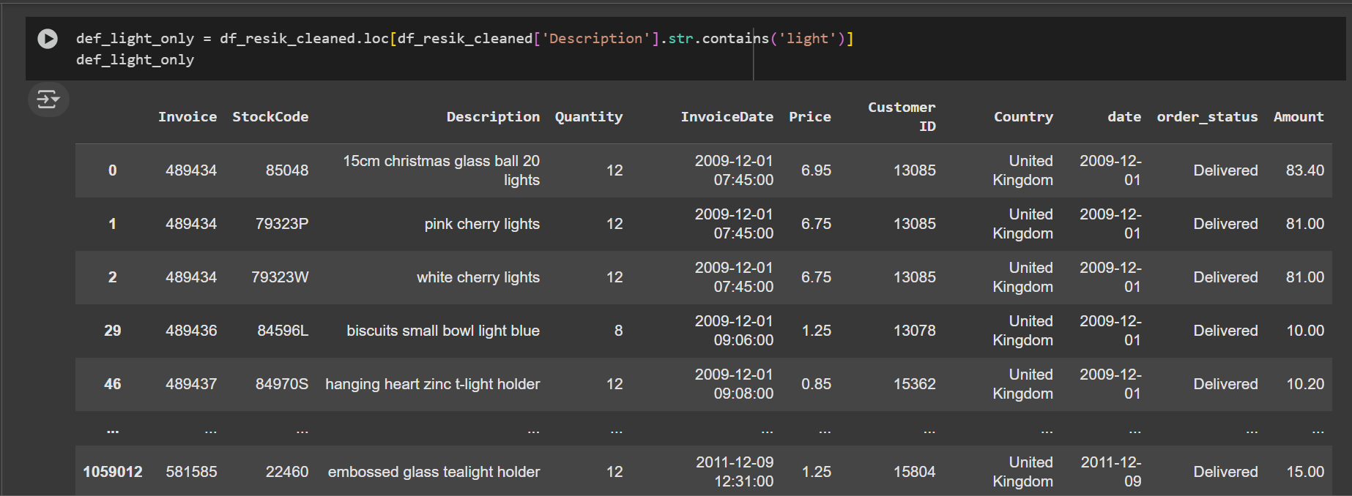



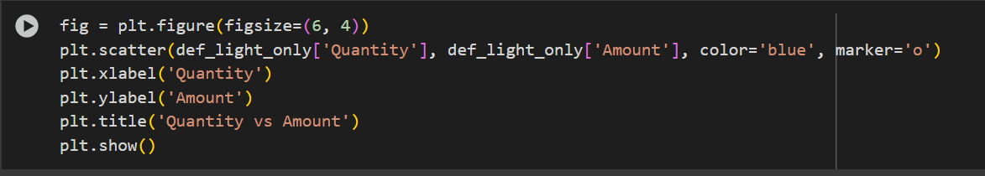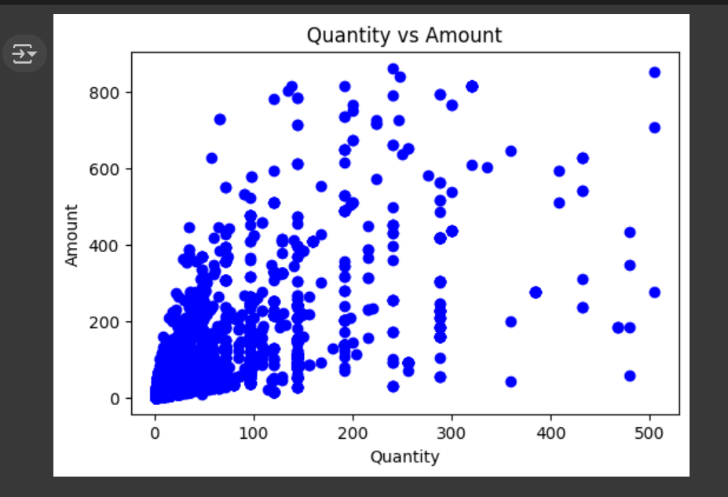

Information :

1. **fig = plt.figure(figsize=(6,4))** Creates a figure (canvas) with a size of 6x4 inches.
2. plt.scatter(def_light_only['Quantity'], def_light_only['Amount'], color='blue', marker='o')
3. **X-axis**: Quantity values from the dataframe def_light_only
4. **Y-axis**: Amount values from the dataframe def_light_only
5. Dots are colored **blue** (color='blue')
6. Dot shape is **circle** (marker='o').
7. **plt.xlabel('Quantity') and plt.ylabel('Amount')** Set the labels for the X and Y axes.
8. **plt.title('Quantity vs Amount')**Adds a title to the plot.
9. Most dots are concentrated in the area with **low Quantity (0–100)** and **low Amount (0–300)**.  
    - This means most transactions involve small quantities with relatively small amounts.
10. Some dots are scattered with **Quantity > 300** and **Amount > 600**, though they are less frequent.  
     - These represent larger or exceptional transactions (possible outliers).
11. The overall distribution shows that while there’s a **general trend** where higher Quantity tends to result in a higher Amount, the relationship is **not perfectly linear**—the points are spread out.

* Correlation



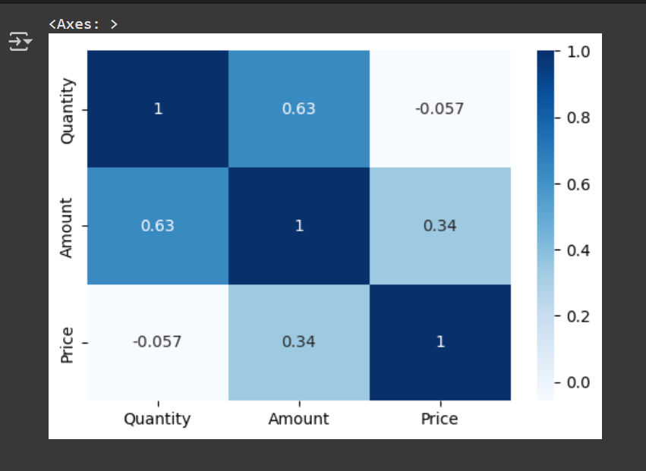

Information :

1. df_resik_cleaned[['Quantity', 'Amount', 'Price']]Selects only the three columns: Quantity, Amount, and Price from the dataframe df_resik_cleaned.
2. .corr() calculates the **correlation matrix** between these columns.

* +1: perfect positive correlation (as one increases, the other always increases).
* -1: perfect negative correlation (as one increases, the other always decreases).
* 0: no correlation

1. sns.heatmap(..., cmap='Blues', annot=True)

* sns.heatmap() creates a **heatmap** visualization of the correlation matrix.
* cmap='Blues': uses a **blue color gradient** for the heatmap.
* annot=True: displays the **numerical correlation values** inside each cell of the heatmap.

1. User Retention
2. Import Library

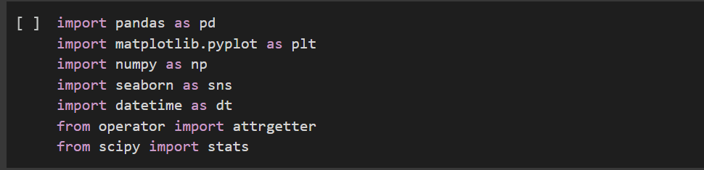

Information : This library that use in this project

1. Import CSV

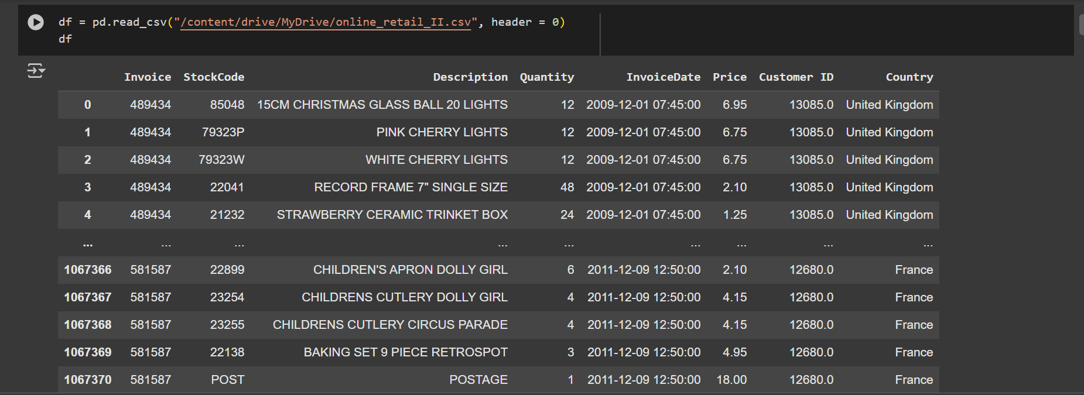

Information : This code import data from CSV and header=0 tells pandas that the first row (row index 0) in the file should be treated as the column names (headers)

1. Data Type

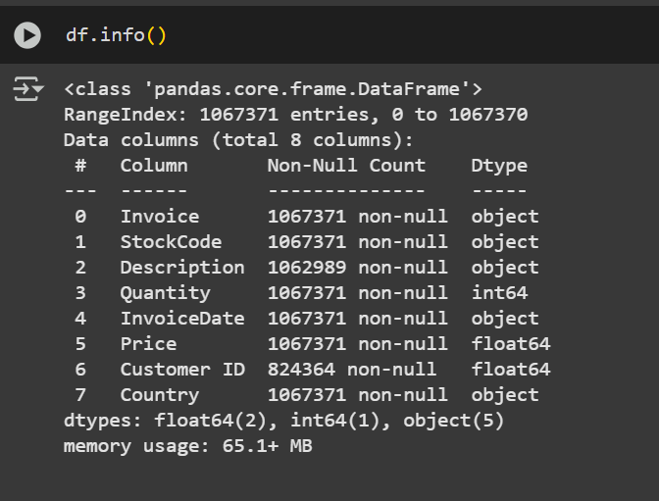

Information : as a represented from data CSV and type data in each column

1. Data Cleaning

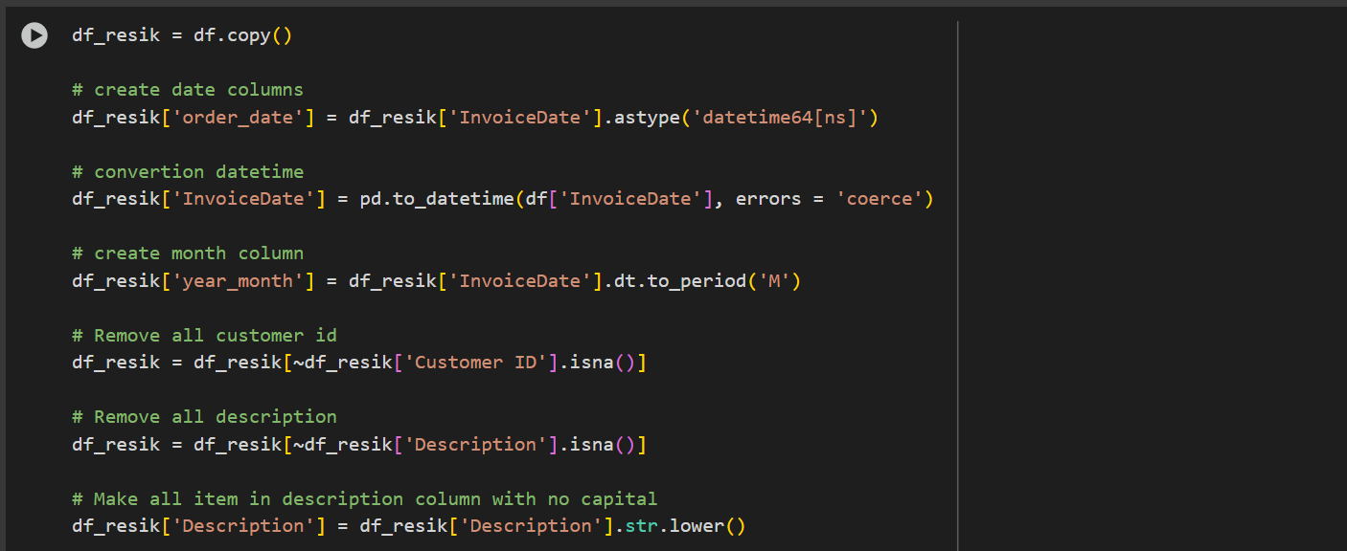

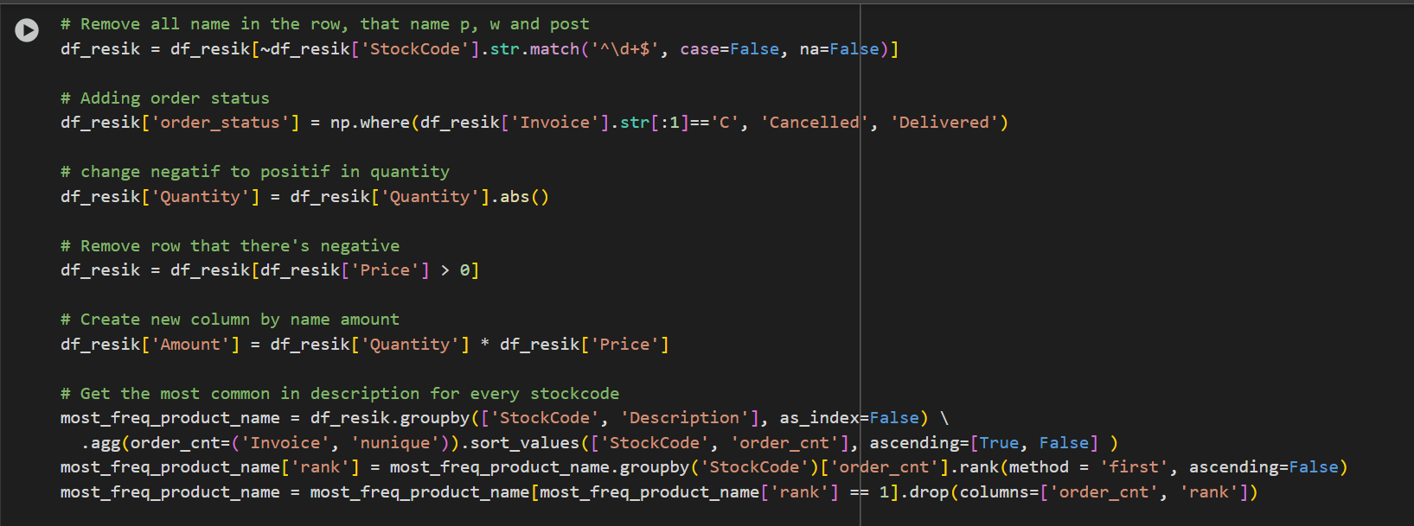

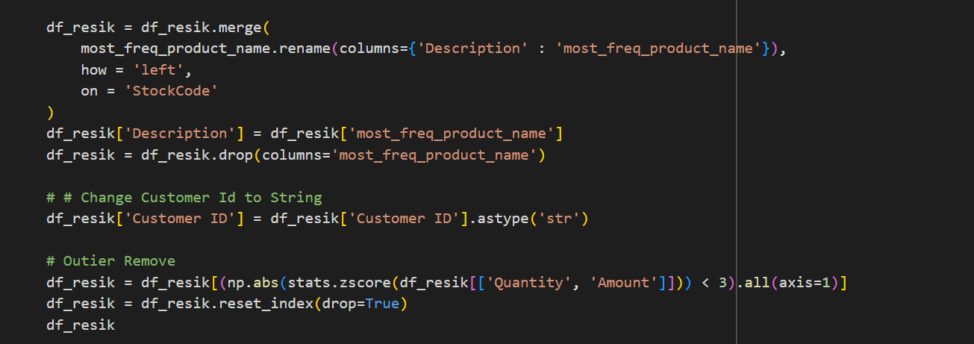

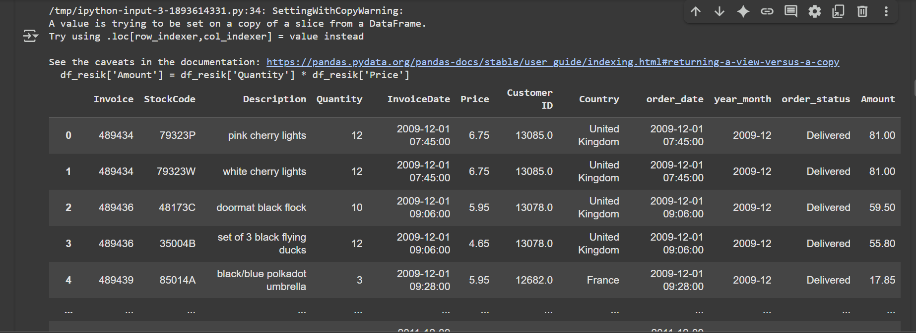

Information :

1. Creates a copy of the dataframe df into df_resik to avoid modifying the original dataset.
2. Converts InvoiceDate into proper datetime format. errors='coerce' will replace invalid date formats with NaT (Not a Time). Also creates a new column order_date for consistency
3. Create Year-Month Extracts year and month from InvoiceDate. Example: "2010-12-01" → "2010-12". Useful for **monthly analysis** (trend, grouping, etc.).
4. Removing missing value Removes rows with missing **Customer ID** or **Description**. Ensures clean data for customer/product analysis.
5. Normalize product descriptions Converts all product descriptions to lowercase. Prevents duplication caused by case differences (e.g., "Lamp" vs "lamp").
6. Filter out unwanted stock codes df_resik = df_resik[~df_resik['StockCode'] Removes rows where StockCode is only numeric (e.g., "12345"). Likely because numeric codes may represent non-product items (like fees, shipping, or errors).
7. Add order status df_resik['order_status']If invoice starts with "C", mark it as **Cancelled**, otherwise **Delivered**. This lets you track transaction status.
8. Fix negative values df_resik['Quantity'] Converts negative Quantity values to positive (e.g., returns/refunds). df_resik[df_resik['Price'] > 0] Removes rows where Price is negative or zero.
9. Create Amount column df_resik['Amount'] Adds a new column Amount = Quantity × Price. Represents total transaction value.
10. Standardize product names by StockCode For each **StockCode**, find the **most common product description**. Standardizes the Description column so that the most frequent name is used consistently. Example: StockCode = 1001 may have descriptions like *"cup"*, *"Cup"*, *"CUP"*. After this step → all become "cup
11. Convert Customer ID to string df_resik['Customer ID'] Ensures Customer ID is treated as categorical/string, not numeric. Useful for grouping and merging.
12. df_resik = df_resik[(np.abs(stats.zscore(df_resik[['Quantity', 'Amount']])) < 3).all(axis=1)] Uses **Z-score method** to remove outliers from Quantity and Amount. Z-score > 3 means a value is more than 3 standard deviations away from the mean (very unusual). Drop those rows and reset the index.
13. Create user retention cohort (Aggregate Data into a summary transaction every user in a month)



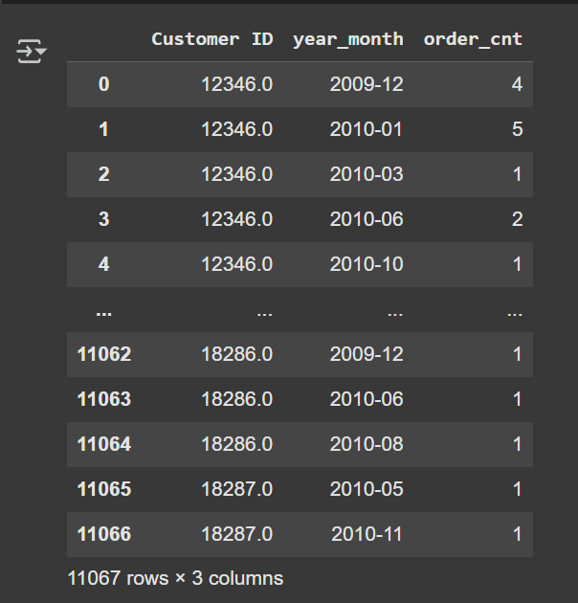

Information :

1. df_resik.groupby(['Customer ID', 'year_month'], as_index=False) You are grouping the dataset df_resik by **Customer ID** and **year_month**. This means you want to analyze activity for **each customer per month**.
2. .agg(order_cnt=('Invoice', 'nunique')) The.agg() function is used to apply aggregations on the grouped data.

* order_cnt → will store the number of **unique invoices** in each group.
* 'nunique' → counts **distinct values** of the column Invoice.

1. Each row = 1 customer in 1 month.
2. order_cnt = number of distinct orders placed by that customer in that month.
3. Create column as cohort from users



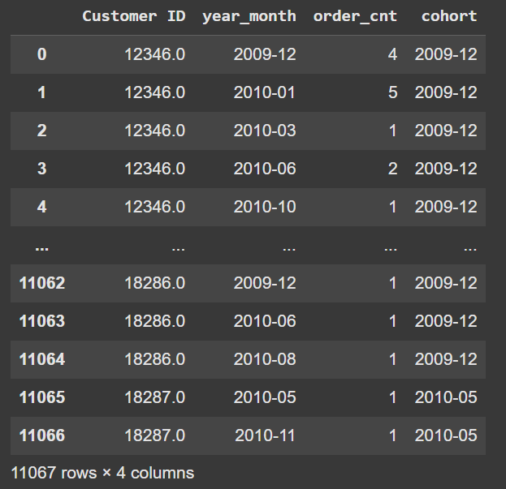

Information :

1. df_user_month.groupby('CustomerID')['year_month'].transform(min)

* Groups the data by **Customer ID**.
* For each customer, it finds the **earliest year_month** (the first month they made a purchase).
* transform(min) ensures that this value is **broadcasted back to all rows** for that customer.
* Example: if Customer A’s first purchase was in **2011-01**, every row belonging to Customer A will have "2011-01" as their cohort

1. df_user_month[‘cohort’]

* Creates a new column cohort in the dataframe.
* The cohort column represents each customer’s **first purchase month**.

1. df_user_month

* Displays the updated dataframe, now with a cohort column.

1. Calculate the month transaction with month transaction first time and add 1 so that the month distance 0 becomes 1 that means first month

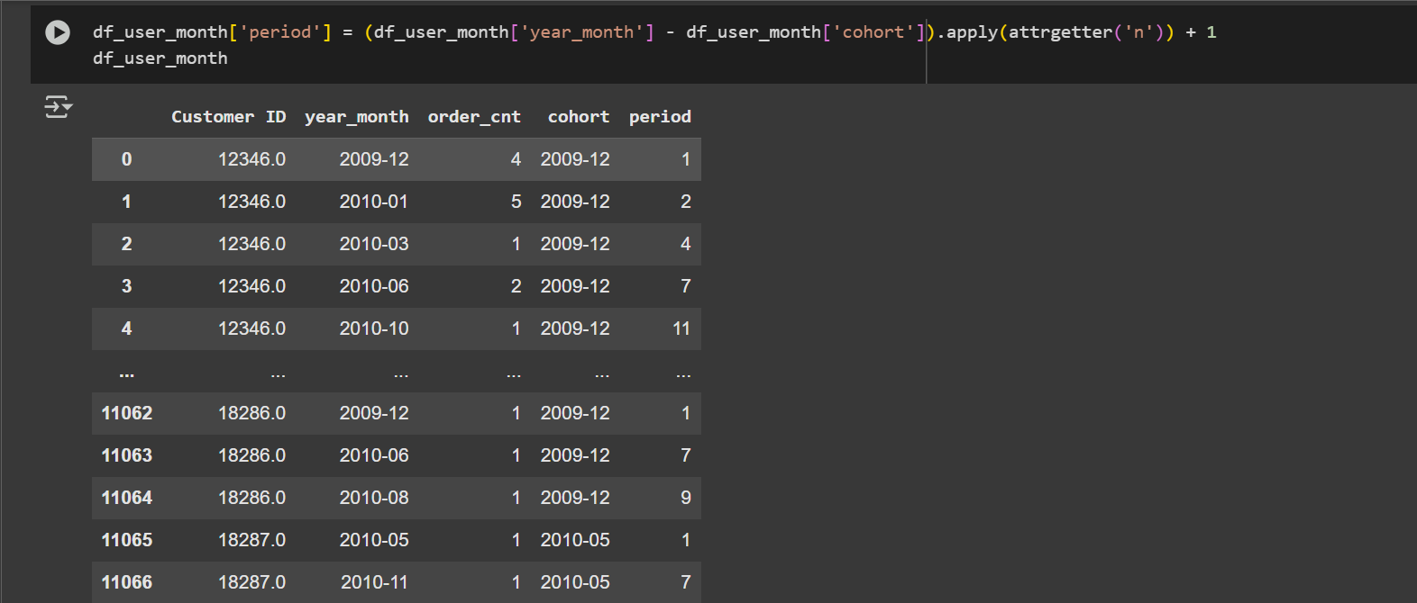



Information :

1. Df_user_month['period'] create new column with name period
2. df_user_month['year_month'] - df_user_month['cohort']

* Both year_month and cohort are in **pandas Period (M)** format.
* Subtracting them gives a **pandas offset (Period difference)** essentially the number of months between a purchase and the customer’s first purchase.

Example : year_month = 2011-03, cohort = 2011-01. Different 2 Months.

1. .apply(attrgetter('n'))

* attrgetter('n') extracts the **numeric value** of the period difference.
* From the example above, "2 months" → 2.

1. + 1

* Adds 1 so that the **cohort’s first month becomes period 1**, not 0.
* If purchase is in the cohort month → period = 1.
* If purchase is 2 months after cohort → period = 3.

1. df_user_month['period'] = Creates a new column period that indicates how many months since the customer’s **first purchase**.
2. pivot tables with index have the shape of cohort, column have the shape of month, and the grade is a many unique user



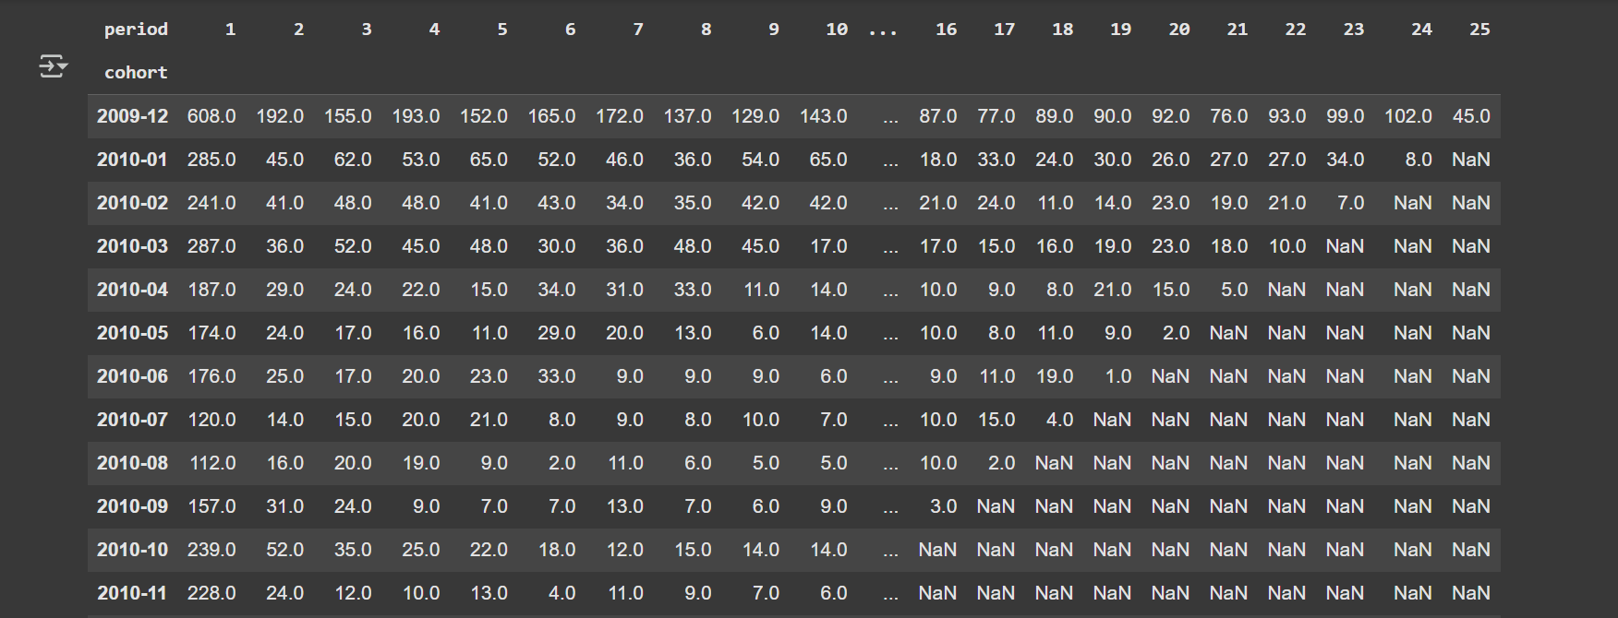

Information :

1. index='cohort' Rows represent **cohort months** (the month when each group of customers made their first purchase).
2. columns='period'

* Columns represent the **period (months since first purchase)**.
* 1 = first purchase month (cohort month).
* 2 = second month after first purchase, and so on.

1. values='Customer ID'

* Uses the Customer ID column to measure unique customers.

1. aggfunc=pd.Series.nunique

* Counts the **number of unique customers** per cohort per period.
* This gives you the **retention count.**

1. Cohort Growth

* The size of each cohort (period 1) varies.
* Example: 2009-12 cohort started with **608 customers**, while 2010-07 started with only **120 customers**.

1. Retention Decay

* Numbers generally **decrease across periods**.
* Example: 2010-01 cohort → from 285 (month 1) down to 8 (month 24).
* This is normal: most customers churn over time, only a small portion stay loyal.

1. Comparing Cohorts

* Some cohorts retain customers better than others.
* Example: 2009-12 cohort shows stronger long-term activity (still 45 active customers in period 25).
* Later cohorts (2010-07, 2010-08) drop off much faster.

1. Calculate many users in every cohort

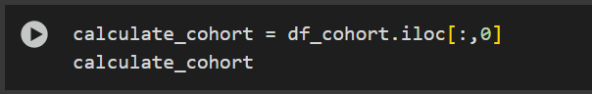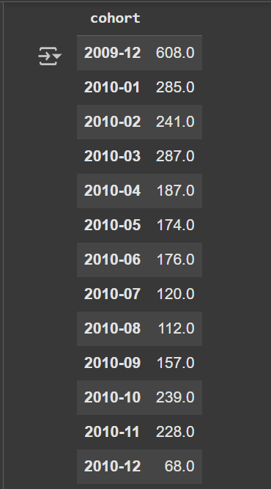

Information :

1. df_cohort

* The index = cohort (the month when each customer first made an order).
* The columns = period (1, 2, 3, … meaning the nth month since the cohort started)
* The values = number of unique customers who placed an order.

1. df_cohort.iloc[:, 0]

* .iloc[:, 0] selects **all rows (:)** and the **first column (0)**.
* That means you are extracting the **first period column** (period 1).

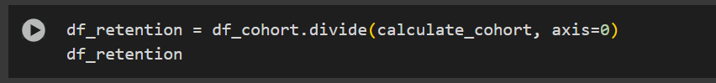

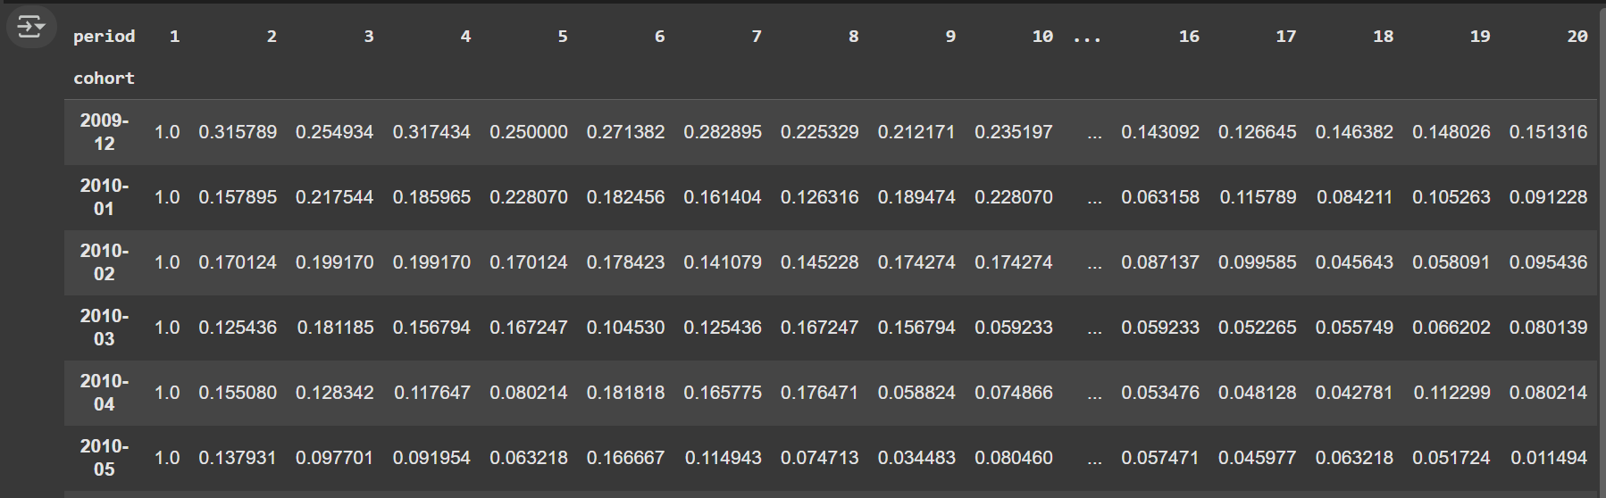

Information :

1. df_cohort = number of active customers by cohort and period.
2. calculate_cohort = first column (baseline size of each cohort).
3. .divide(..., axis=0) = divides each row by its baseline size → **retention ratio**.
4. Cohort (row index)

* Example: 2009-12 = customers whose **first order** was in December 2009.
* Each row tracks this group over time.

1. Values (fractions)

* Example: For cohort 2010-01, at period 2 the value is 0.157895 (~16%).  
   → This means only **16% of Jan 2010’s new customers were still active** in the 2nd month.
* By period 19, that drops to ~9%.

1. Period (columns 1, 2, 3, …)

* Period 1 = their first active month (always 1.0 = 100%).
* Period 2 = the following month.
* Period 3 = two months later, and so on.
* Period 20 = twenty months later.

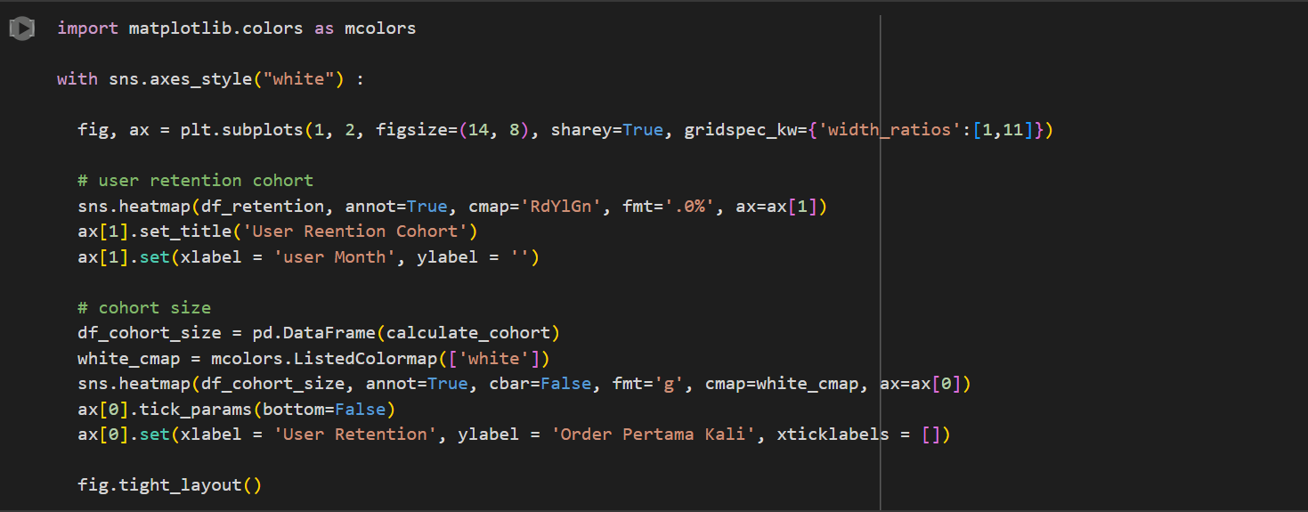

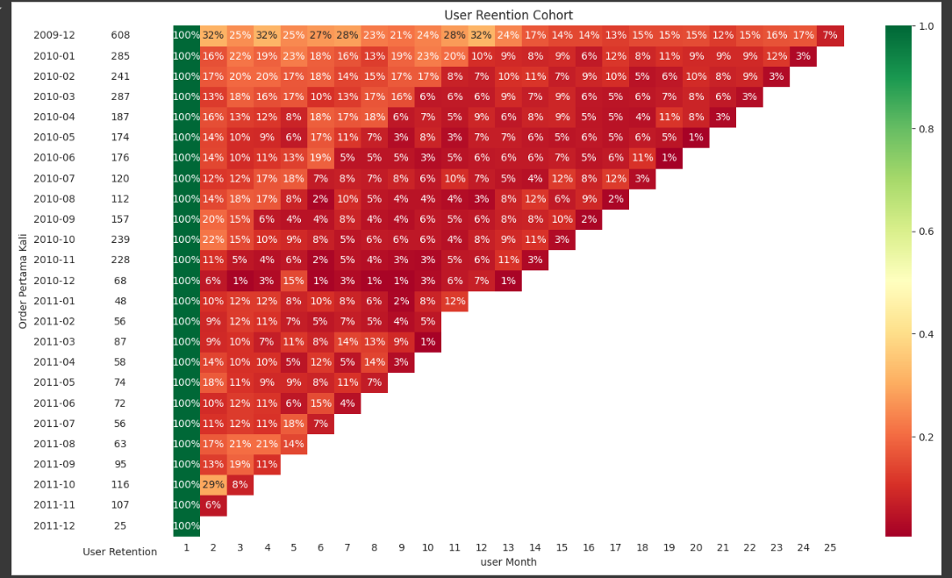

Information :

1. Plots **df_retention** as a heatmap.

* annot=True → shows numbers inside cells.
* cmap='RdYlGn' → Red-Yellow-Green colormap (red = low retention, green = high).
* fmt='.0%' → formats values as percentages.

1. Title = "User Retention Cohort".
2. X-axis = "user Month" (period 1,2,3…).
3. Y-axis = empty ('') since cohorts are already labeled.
4. Creates a small heatmap of **cohort sizes** (number of customers in each starting month).
5. Uses a **white colormap** so the background is white, only numbers are shown.
6. cbar=False → no colorbar.
7. fmt='g' → shows raw numbers (integer).
8. Removes x-tick labels (xticklabels=[]) so only cohort names show on y-axis.
9. Y-axis label = "Order Pertama Kali" → first order month.
10. This chart shows **customer retention decay over time**. On average, only **10–20%** of customers return after the second month, and **less than 5–10%** remain active beyond the 10th month. Early cohorts had stronger loyalty, but retention weakened in later ones.
11. User Segmentation
12. Import Library

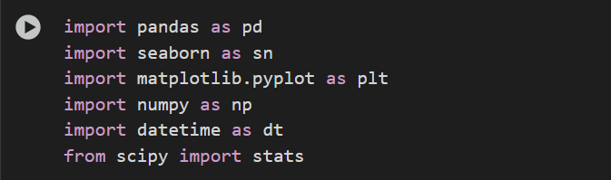

Information : This library that use in this project

1. Import CSV

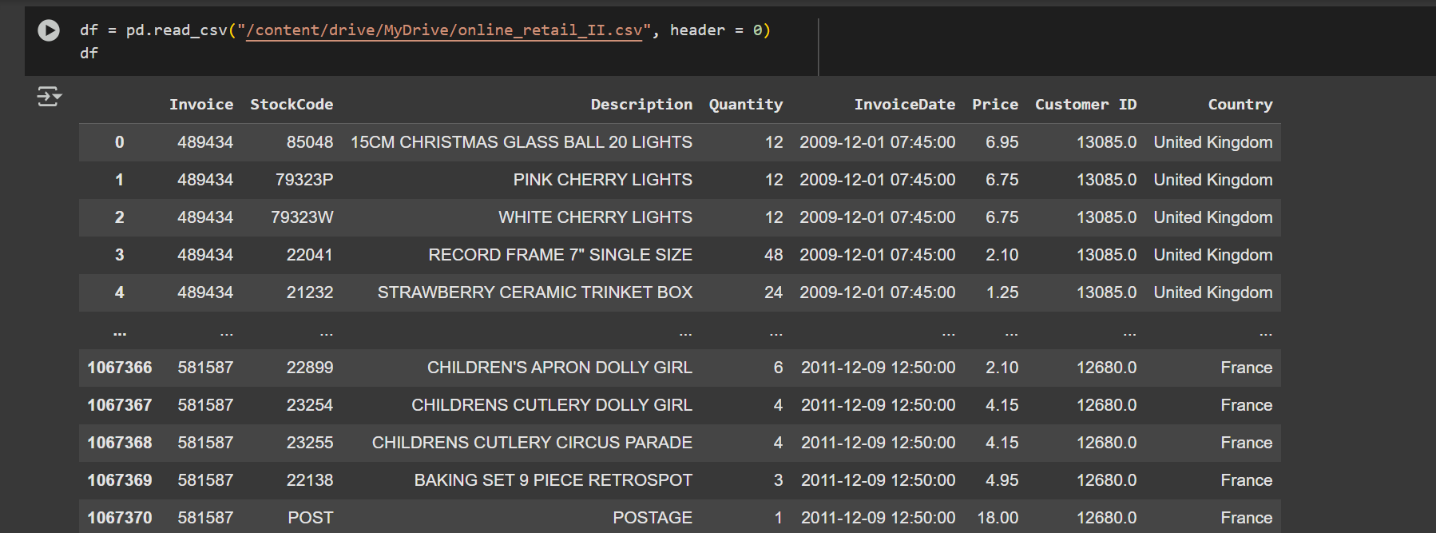

Information : This code import data from CSV and header=0 tells pandas that the first row (row index 0) in the file should be treated as the column names (headers)

1. Info Type Data

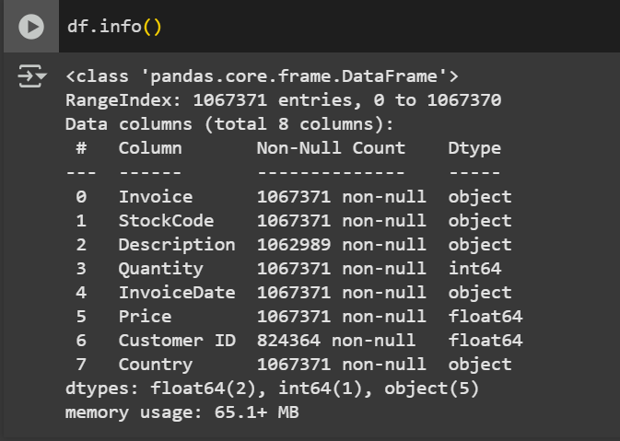

Information : as a represented from data CSV and type data in each column

1. Data Cleaning

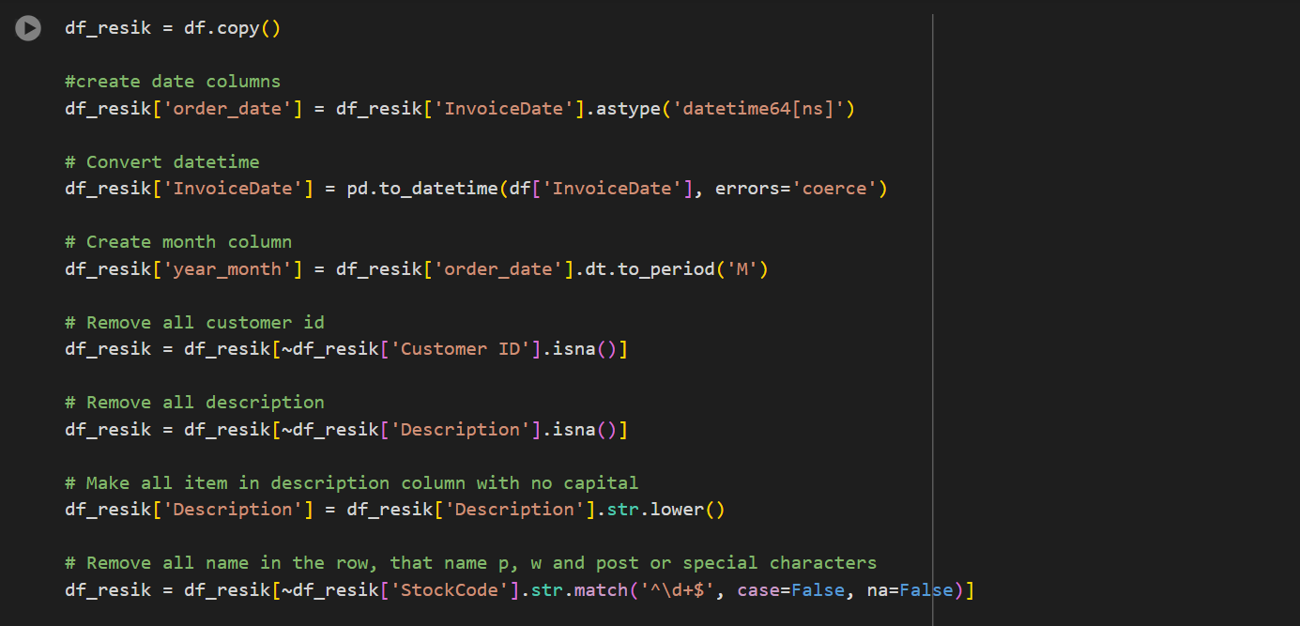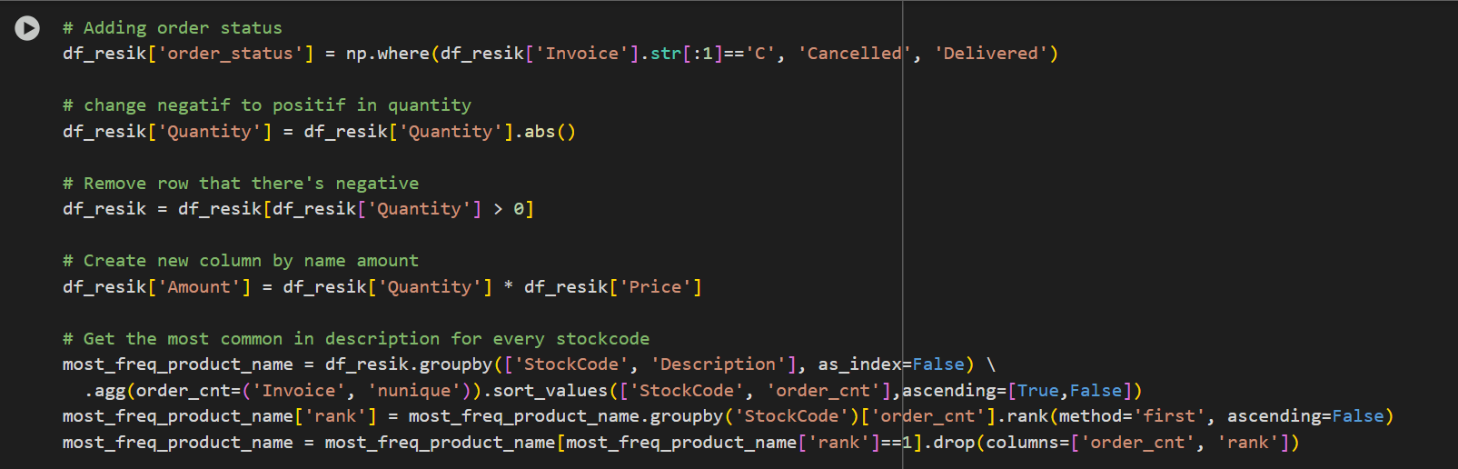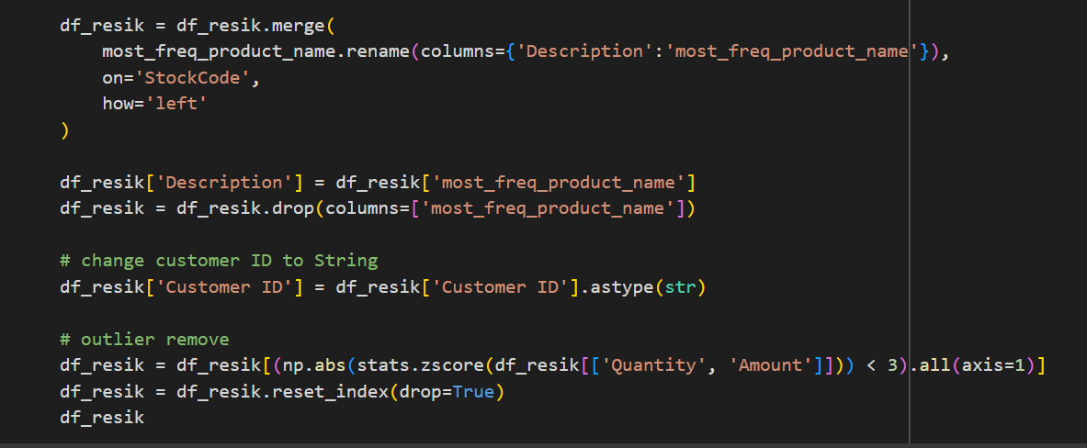

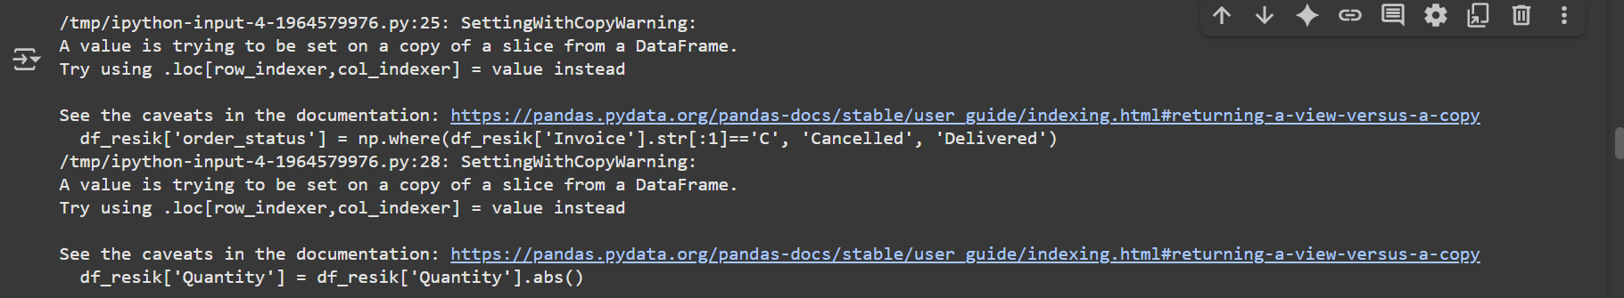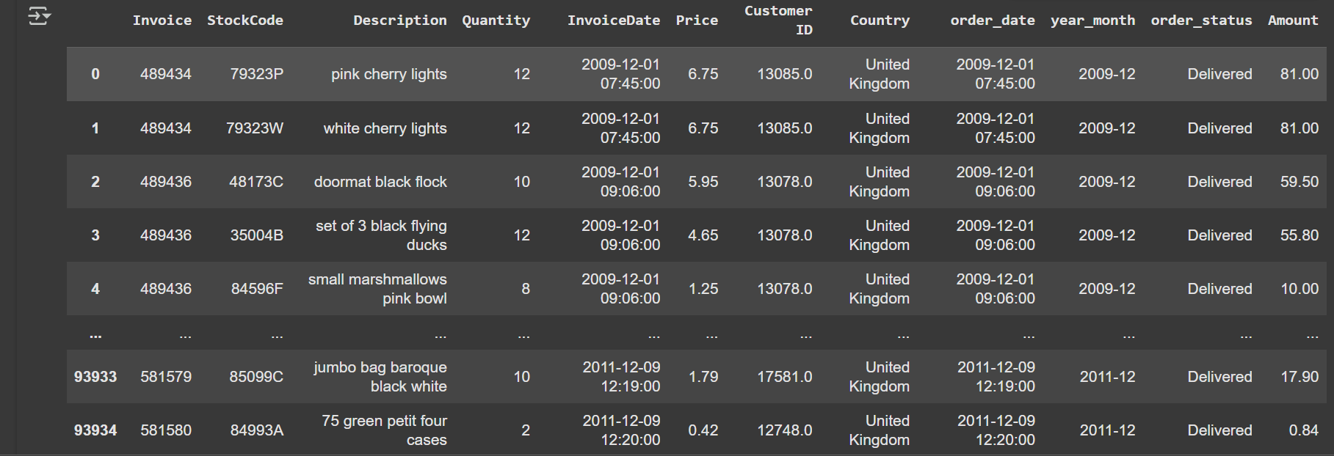

Information :

1. df_resik = df.copy() Creates a **clean copy** of the original dataset called df_resik (so you don’t modify df directly).
2. Create and convert date columns. (df_resik['order_date'] ) (df_resik['InvoiceDate'])

* order_date = explicit datetime version of InvoiceDate.
* Ensures InvoiceDate is stored as a proper datetime (coerce turns invalid values into NaT).

1. Create **year-month** column | df_resik['year_month'] |

* Extracts just the **year-month period** (e.g. 2010-12, 2011-01).
* Useful for cohort analysis and time-based grouping.

1. Drop missing values Removes rows with missing Customer ID or missing product Description.
2. df_resik['Description'] Converts all product descriptions to lowercase for consistency.
3. Clean StockCode values df_resik = df_resik[~df_resik['StockCode']

* Removes rows where StockCode is only digits (likely not a real product, but a placeholder like "12345" or shipping codes).
* Keeps only codes with letters (actual product IDs).

1. Add order status df_resik['order_status']

* If Invoice starts with "C", mark as "Cancelled". Otherwise "Delivered".
* This helps separate valid vs canceled orders.

1. Fix quantities | df_resik['Quantity'] | df_resik[df_resik['Quantity'] > 0]

* Converts all negative quantities to positive.
* Then removes rows with Quantity <= 0 (invalid).

1. Create sales amount df_resik['Amount'] Adds a new Amount column = revenue per row
2. Standardize product naming most_freq_product_name

* For each StockCode, find the **most common product name** (sometimes the same stock code has slightly different descriptions).
* Keeps only the most frequent description for each product

1. df_resik = df_resik.merge

* Merges that standardized description back into df_resik.
* Replaces messy Description with the **canonical name**.

1. Convert Customer ID to string Ensures Customer ID is string (so you don’t get problems with numeric IDs like 12345.0).
2. Remove outliers

* Uses **Z-score method** to remove outliers in Quantity and Amount (anything more than 3 standard deviations away is dropped).
* Resets the index after filtering.

1. Create RFM Segmentation (Aggregate transaction data into a summary form of total transactions (orders), total order value (order value), last order date for each user)

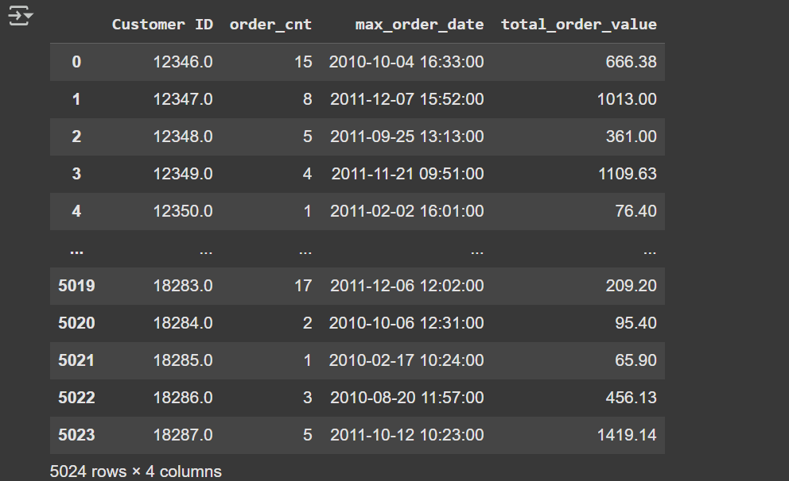

Information :

1. df_resik.groupby('Customer ID', as_index=False)

* This groups your dataset (df_resik) by **Customer ID**.
* Each row in the new DataFrame will represent **one customer** instead of individual transactions.

1. .agg(...)

* You’re aggregating multiple metrics for each customer:
* **order_cnt=('Invoice', 'nunique')** → Counts how many **unique invoices** each customer has (basically, how many separate orders they made).  
   ✅ Example: if a customer bought 5 times but 2 were from the same invoice → order count = 4.
* **max_order_date=('order_date', 'max')** → Gets the **latest order date** for each customer (the most recent purchase).  
   ✅ Useful for checking **recency** of activity.
* **total_order_value=('Amount', 'sum')** Sum up the **Amount** column (which is Quantity × Price) for each customer.  
   ✅ This gives you the **total revenue contributed by the customer**.

1. Result: df_user_month

* customer-level summary DataFrame with **one row per customer**, containing:
* Customer ID → identifier
* order_cnt → number of unique orders
* max_order_date → last purchase date
* total_order_value → total spending

1. create column calculate day since last order

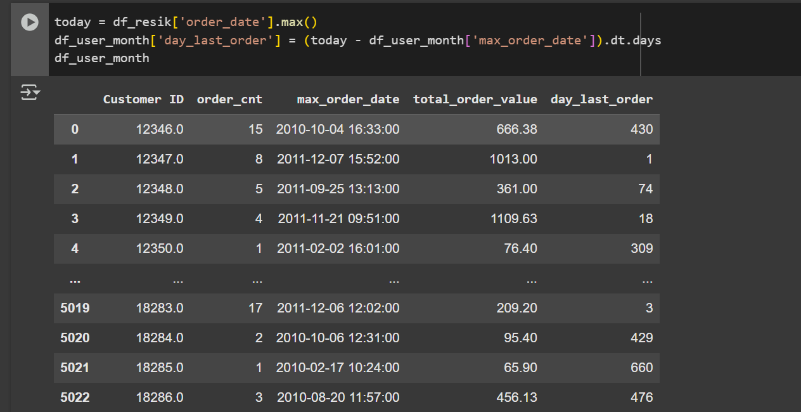

Information :

1. today = df_resik['order_date'].max()

* Looks at the **entire dataset** (df_resik['order_date'])
* Finds the **latest date** (max).
* Store it today.
* This acts like the "current day" for analysis (since in historical data you don’t always know the real today).

1. Calculate recency in days df_user_month['day_last_order']

* For each customer, subtract their **last purchase date** (max_order_date) from the dataset’s latest date (today).
* The result is a **Timedelta** object.
* .dt.days converts it into an integer number of days.

1. **Result** df_user_month now includes an extra column day_last_order
2. **R** (Recency): day_last_order (how long since the last purchase)
3. **F** (Frequency): order_cnt (how many orders)
4. **M** (Monetary): total_order_value (how much they’ve spent)

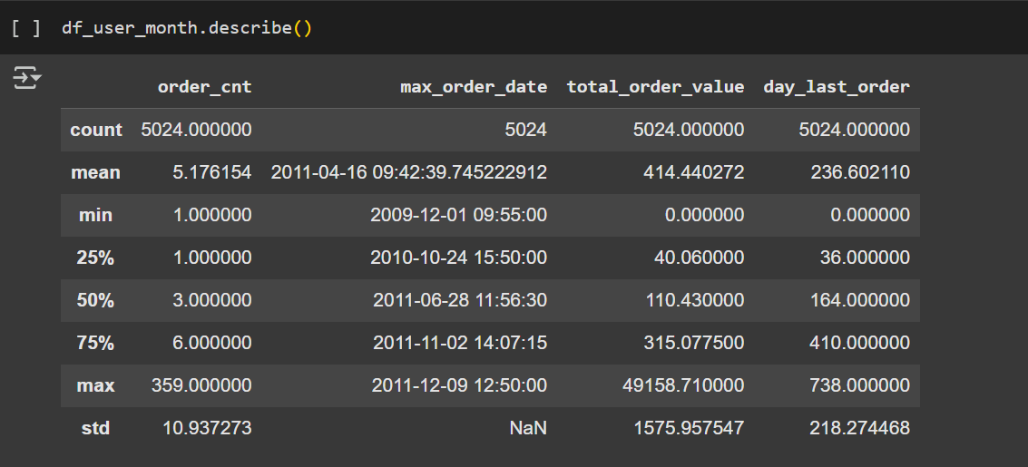

Information : This code explains the function of describing the amount of statistics simple like sum, percentile, mean, min,max, std.

1. Create a binning of the number of days since the last order consisting of 5 bins with the boundaries being min, P20, P40, P60, P80, max and label 1 to 5 from highest to lowest bin as the current score

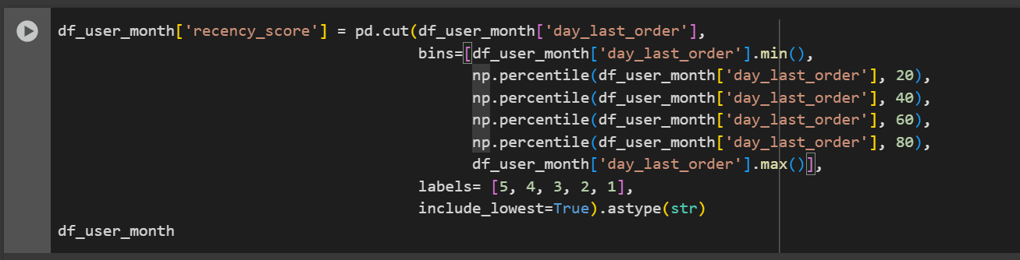

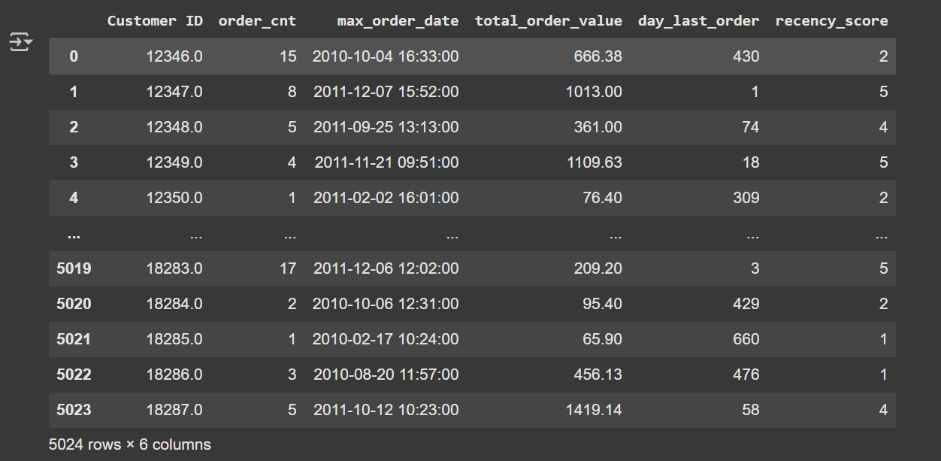

Information :

1. df_user_month['day_last_order'] → the number of days since last purchase (lower = more recent).
2. **Define bins** (cut points for categorization):

* Start = min() → the most recent customer (smallest days since purchase).
* Then break at **20th, 40th, 60th, 80th percentiles** → divides customers into 5 equal-sized groups by recency.
* End = max() → the least recent customer (largest days since purchase).

1. Labels (scores)

* [5, 4, 3, 2, 1]
* So the **most recent 20%** of customers get **score = 5**.
* The **least recent 20%** get **score = 1**.

1. **include_lowest=True** Ensures the very lowest value (e.g., 0 days since last order) is included in the first bin.
2. **astype(str)** Converts the scores to string (useful if later you want to concatenate with frequency/monetary scores like "543").

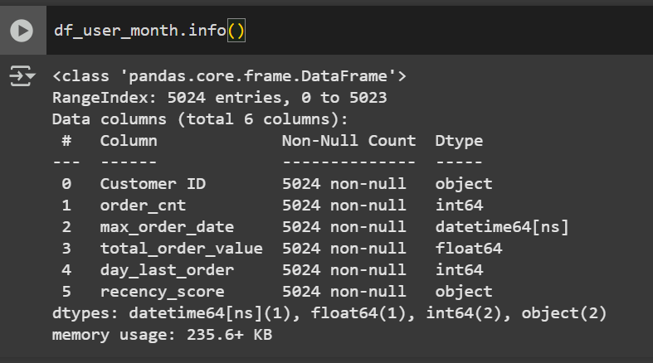

Information : this is info from data for every column in df_user_month

1. Create a binning of total transactions (orders) consisting of 5 bins with the boundaries being min, P20, P40, P60, P80, max and label them 1 to 5 from lowest to highest bin as frequency score

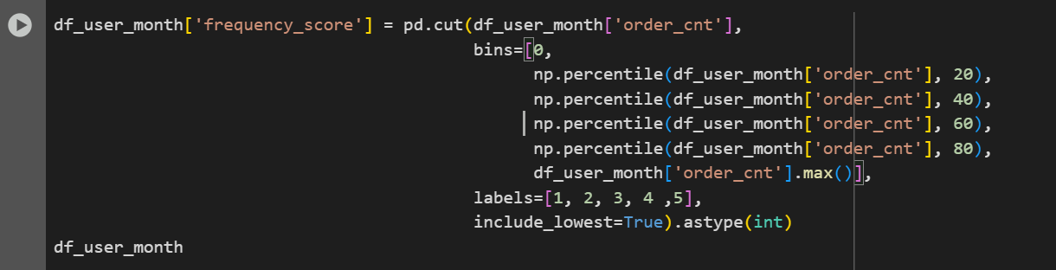

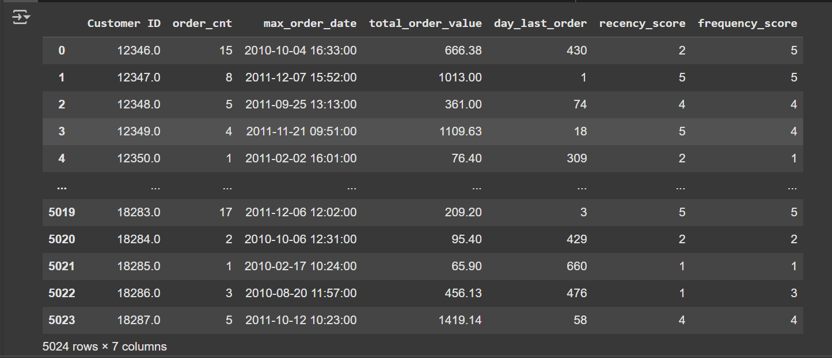

Information :

1. order_cnt = how many **unique orders** each customer has placed.
2. Define bins

* Start from 0 (minimum possible order count).
* Then cut by **20th, 40th, 60th, 80th percentiles** of order_cnt.
* End at max() (highest number of orders among all customers)

1. Labels (scores)

* [1, 2, 3, 4, 5]
* Higher order count = better score.
* So customers with the most purchases get **5**, while those with the fewest get **1**.

1. **include_lowest=True** Ensures customers with very low values (like exactly 0 or 1 orders) are included in the lowest bin.
2. **astype(int)** Converts the category labels into numeric integers (handy for math later).
3. Create a binning of total transactions (monetary_score) consisting of 5 bins with the boundaries being min, P20, P40, P60, P80, max and label them 1 to 5 from lowest to highest bin as frequency score

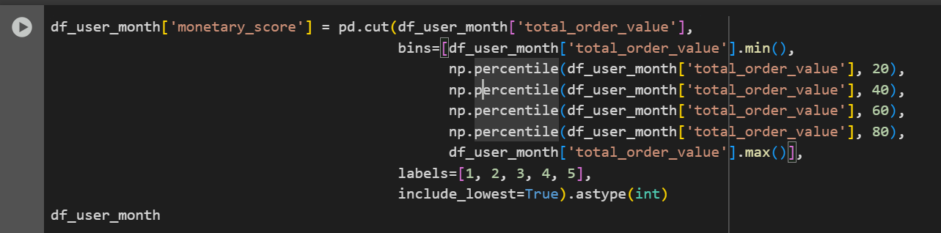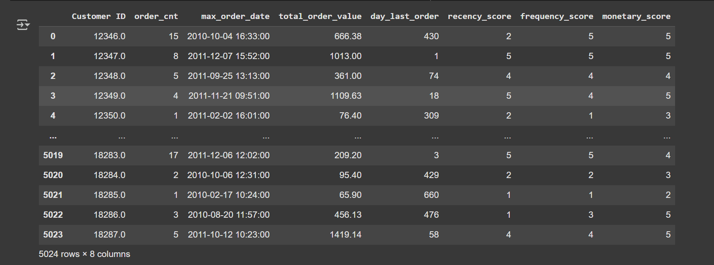

Information :

1. total_order_value = total amount (money spent) by each customer.
2. From min() purchase value (lowest spender) to max() (highest spender).
3. Divided into **percentile cutoffs (20%, 40%, 60%, 80%)** → basically splitting customers into 5 groups based on how much they spend.
4. Labels (Score) [1, 2, 3, 4, 5]

* Customers with the highest spend → 5.
* Customers with the lowest spend → 1.

1. **include_lowest=True** Ensures the customer with the minimum spend is included properly.
2. **astype(int)** Converts the bin labels from category to integer type.
3. Create a segment name column based on recency and frequency scores

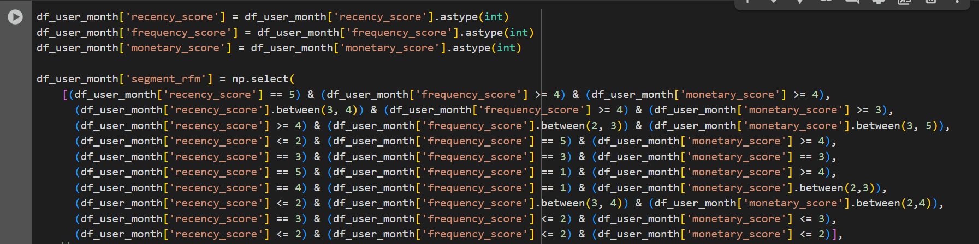

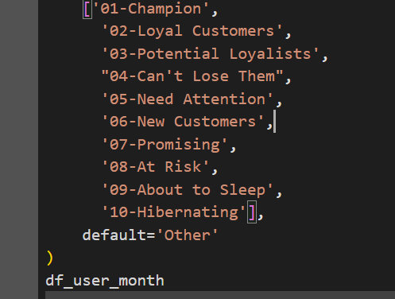

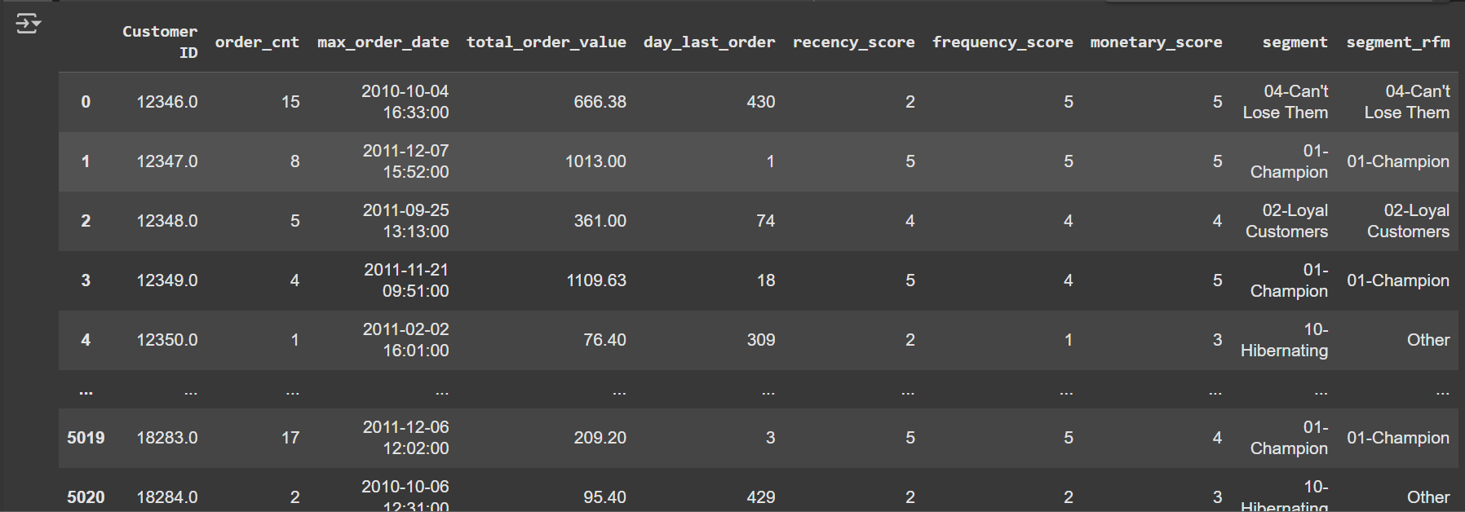

Information :

1. Convert score to int df_user_month['recency_score'], df_user_month['frequency_score'], df_user_month['monetary_score']

* Make sure all three scores are integers (not categorical).
* This is needed because np.select conditions compare numerical values.

1. Segmenting customers

* np.select() works like a **multi-condition IF-ELSE**.
* Each condition maps to a customer segment.

1. Segment Explanation
2. 01-Champion

* recency_score = 5 (recent buyers)
* frequency_score >= 4 (buy very often)
* monetary_score >= 4 (spend a lot)  
   → Your **best customers** 🏆

1. 02-Loyal Customers

* recency_score = 3–4 (fairly recent)
* frequency_score >= 4 (buy often)
* monetary_score >= 3 (spend well)  
   → **Repeat buyers who trust your brand.**

1. 03-Potential Loyalists

* recency_score >= 4 (recent)
* frequency_score = 2–3 (medium frequency)
* monetary_score = 3–5 (spend good money)  
   → Newer customers with potential to become loyal.

1. 04-Can't Lose Them

* recency_score <= 2 (haven’t bought for a while)
* frequency_score = 5 (used to buy a lot)
* monetary_score >= 4 (used to spend a lot)  
   → Big spenders who **are slipping away** ⚠️

1. 05-Need Attention

* recency_score = 3
* frequency_score = 3
* monetary_score = 3  
   → Middle group, may go either way (good to nurture).

1. 06-New Customers

* recency_score = 5 (just bought)
* frequency_score = 1 (only once)
* monetary_score >= 4 (spent big first time)  
   → Newly acquired customers with high potential

1. 07-Promising

* recency_score = 4
* frequency_score = 1 (not often)
* monetary_score = 2–3 (small–medium spend)  
   → Early-stage customers who **could grow.**

1. 08-At Risk

* recency_score <= 2 (long ago)
* frequency_score = 3–4 (used to buy fairly often)
* monetary_score = 2–4 (used to spend decent amount)  
   → Customers **losing engagement**.

1. 09-About to Sleep

* recency_score = 3
* frequency_score <= 2
* monetary_score <= 3  
   → Low engagement, may **churn soon**

1. 10-Hibernating

* recency_score <= 2
* frequency_score <= 2
* monetary_score <= 2

→ Dormant, barely active customers.

1. Display a summary of RFM segmentation (point 8) in the form of number of users, average and median of total orders, total order value, and number of days since the last order

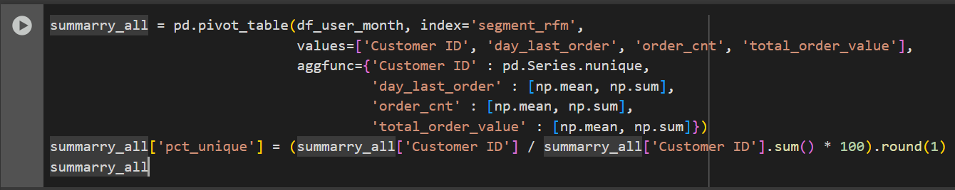

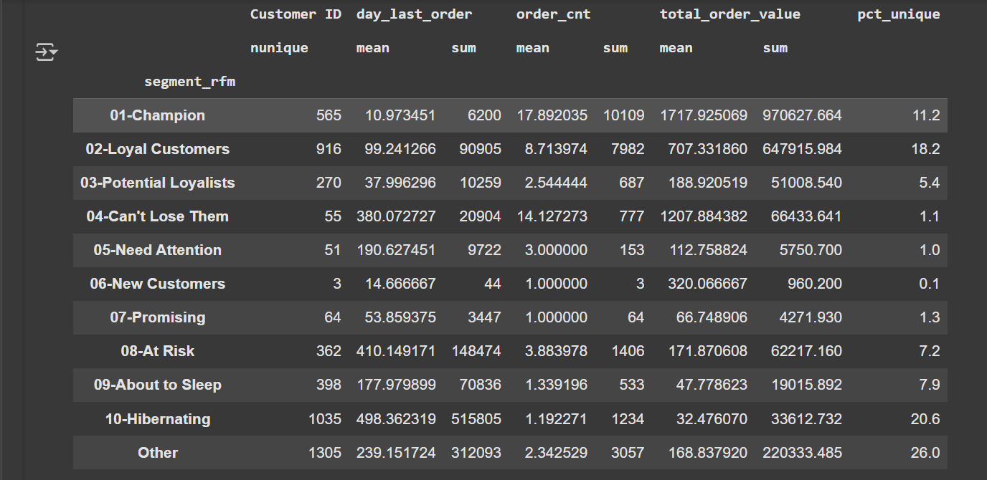

Information :

1. Pivot Table

* index='segment_rfm' → Each row is one customer segment.
* **values=...** → Metrics to calculate:
* Customer ID → Count of unique customers
* day_last_order → Days since last order (recency proxy)
* order_cnt → Frequency  
  total_order_value → Monetary value
* aggfunc=... → For each metric:
* Customer ID: count unique customers
* day_last_order: mean & sum
* order_cnt: mean & sum
* total_order_value: mean & sum

### **Percentage of Customers**

* Divides each segment’s customer count by total customers.
* Multiplies by 100 → **percentage distribution of customers across segments**.
* Rounded to 1 decimal place.

1. Last Analysis Project 1
2. Import Library

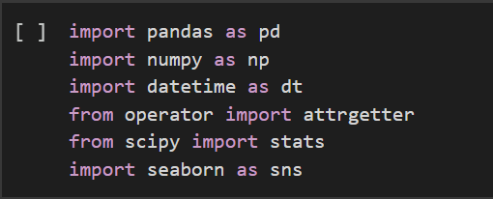

Information : This library that use in this project

1. Import CSV

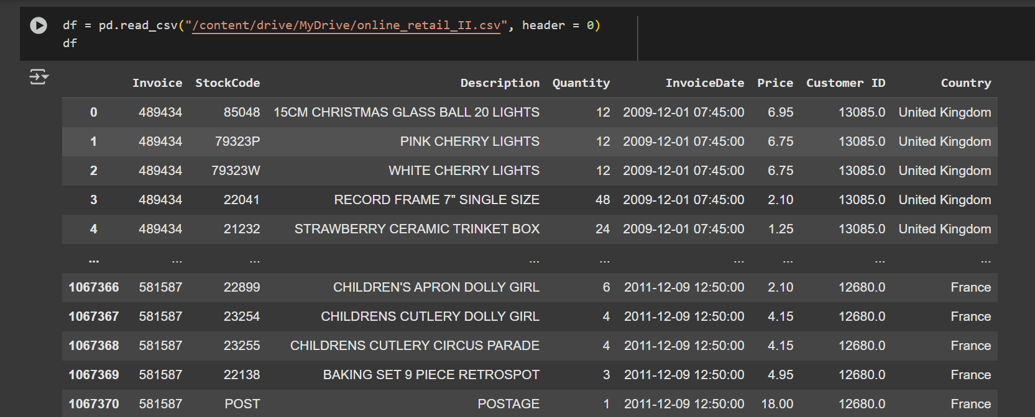

Information : This code import data from CSV and header=0 tells pandas that the first row (row index 0) in the file should be treated as the column names (headers)

1. Data Cleaning

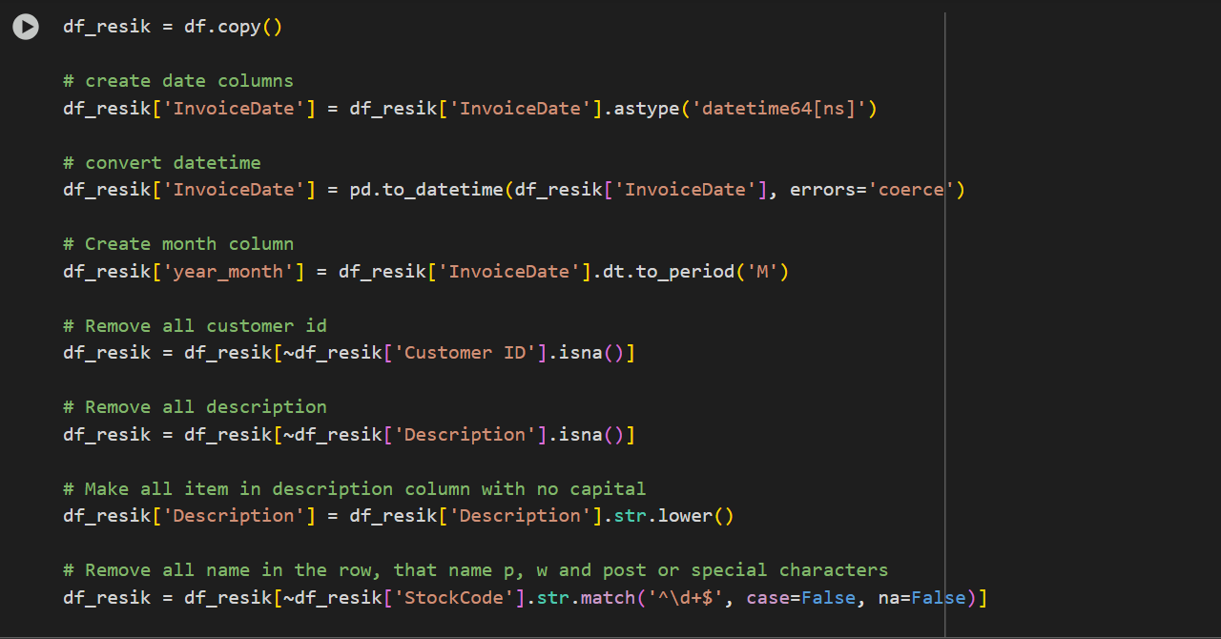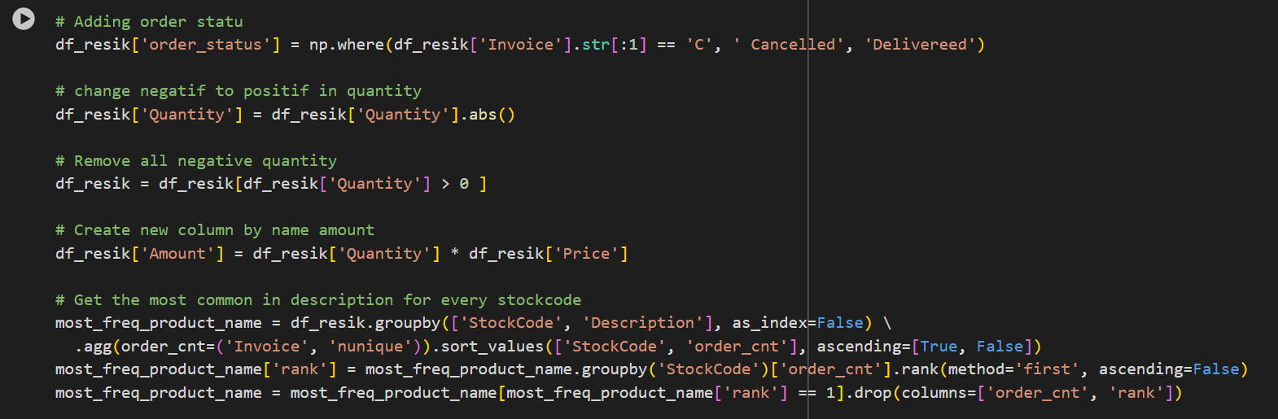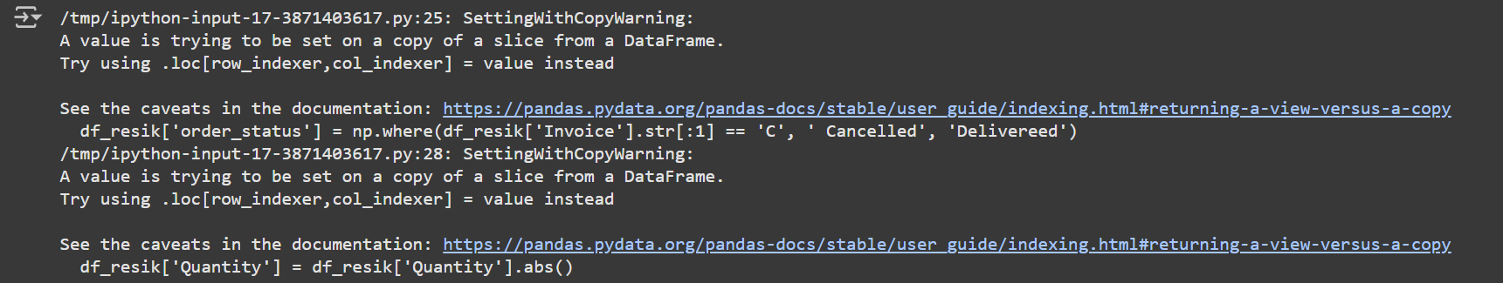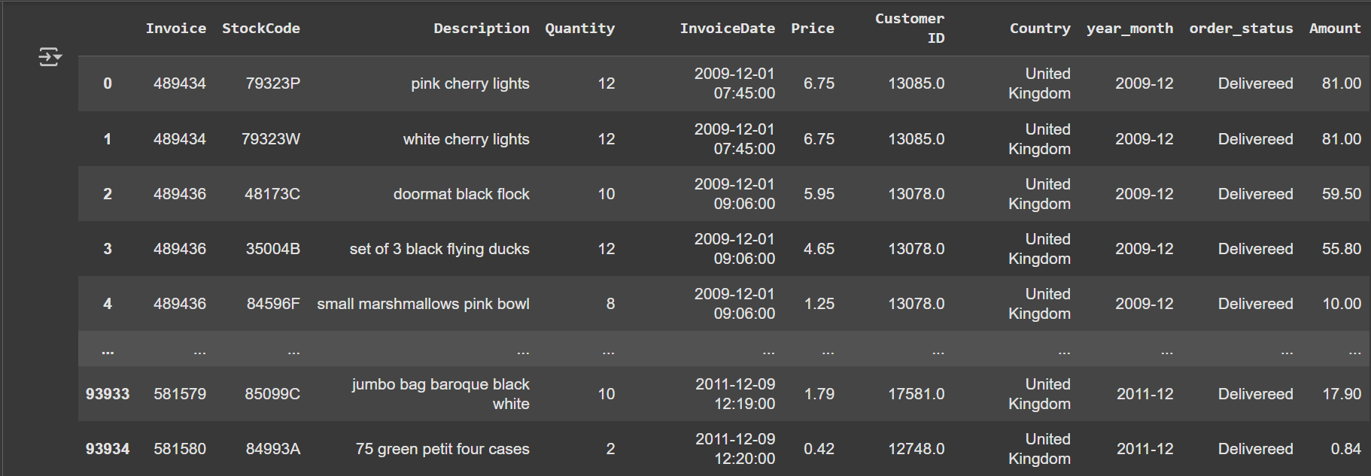

Information :

1. df_resik = df.copy() Makes a clean working copy of the original dataset.
2. Handle date columns

* Convert InvoiceDate to datetime format.
* Create a new column year_month representing the transaction period (month & year).

1. Remove invalid records

* Exclude rows with missing Customer ID or missing Description.
* Convert all product descriptions to lowercase for consistency.
* Remove rows where StockCode contains only numbers (likely not useful).

1. Order status column

* If Invoice starts with "C" → **Cancelled**.
* Otherwise → **Delivered**.

1. Fix quantity values

* Convert negative quantities to positive.
* Remove any records with quantity ≤ 0.

1. **Amount column** Adds Amount = Quantity × Price, representing total sales per row.
2. Standardize product names

* For each StockCode, find the most frequent product description.
* Replace Description with this most frequent name to avoid inconsistencies.

1. **Customer ID formatting** Convert Customer ID to string to keep it consistent.
2. Outlier removal

* Keeps only rows where values are within 3 standard deviations.
* Reset index after filtering.

1. Data Type

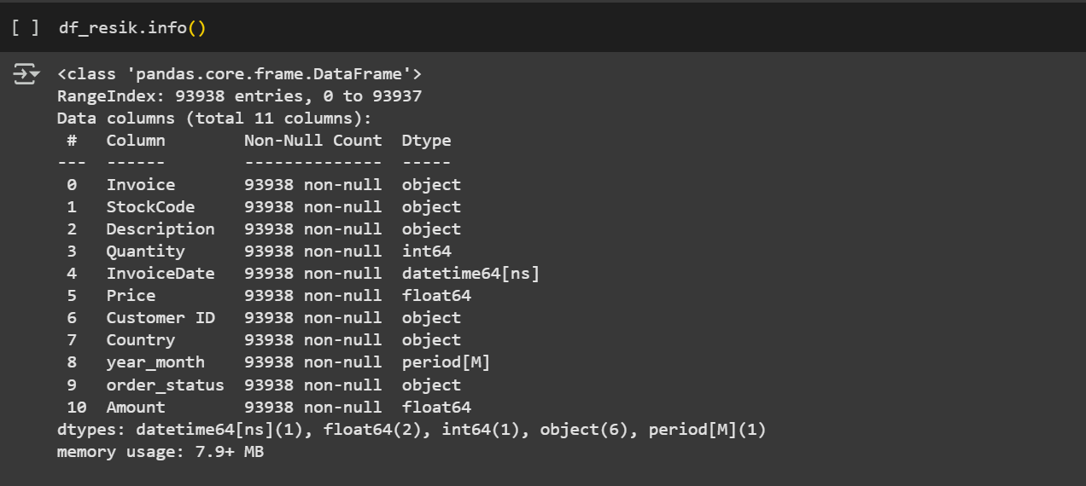

Information : as a represented from data CSV and type data in each column

1. Already data (Create data frame data)



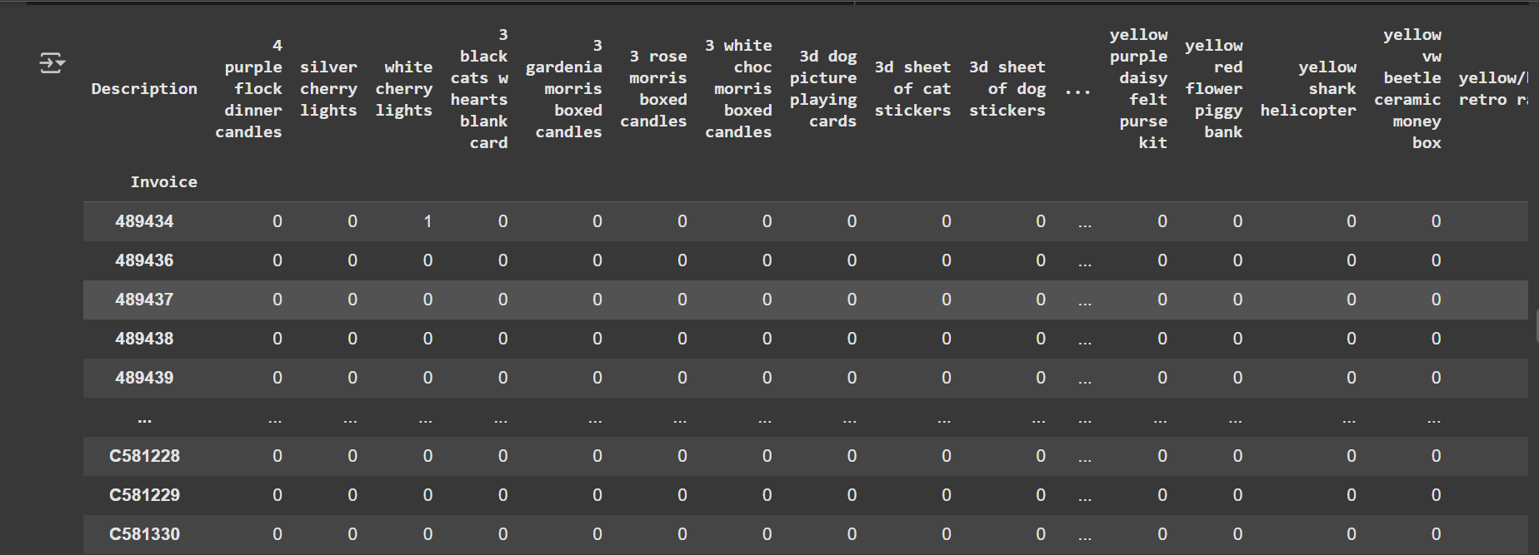

Information :

1. **Pivot Table Creation**You’re making a pivot table from your cleaned dataset df_resik.
2. **index='Invoice'**

Each row in the pivot table represents a unique **Invoice** (a single transaction/order).

1. **columns='Description’**

* Each column is a product name **(Description)**.
* So, across the columns, you’ll see all products from the dataset.

1. **values='Quantity'**

* You’re focusing on the **Quantity** column for aggregation.

1. **aggfunc='nunique'**

* **Instead** of summing quantities, it counts the number of unique values of Quantity for each (Invoice, Product) combination.
* **1 →** means the product appears in that invoice **(with some quantity)**
* **0 →** means the product does not appear in that invoice.

1. fill_value=0

Missing values (when a product wasn’t purchased in a given invoice) are replaced with 0.

1. Info type

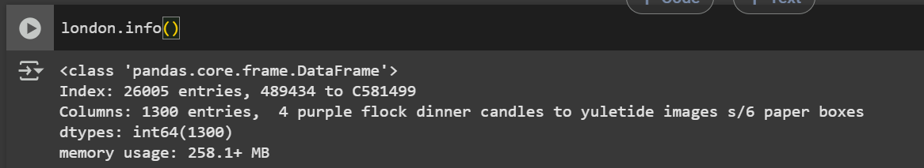

Information : The output shows metadata about your pivot table london

1. Encode DataFrame basket dengan nilai True untuk semua nilai di atas 0 dan False untuk semua nilai 0

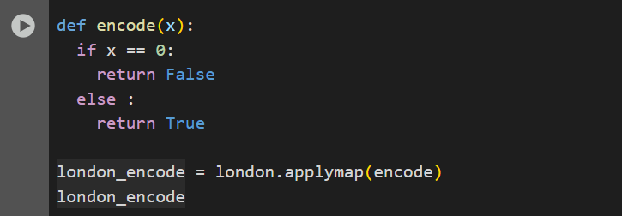

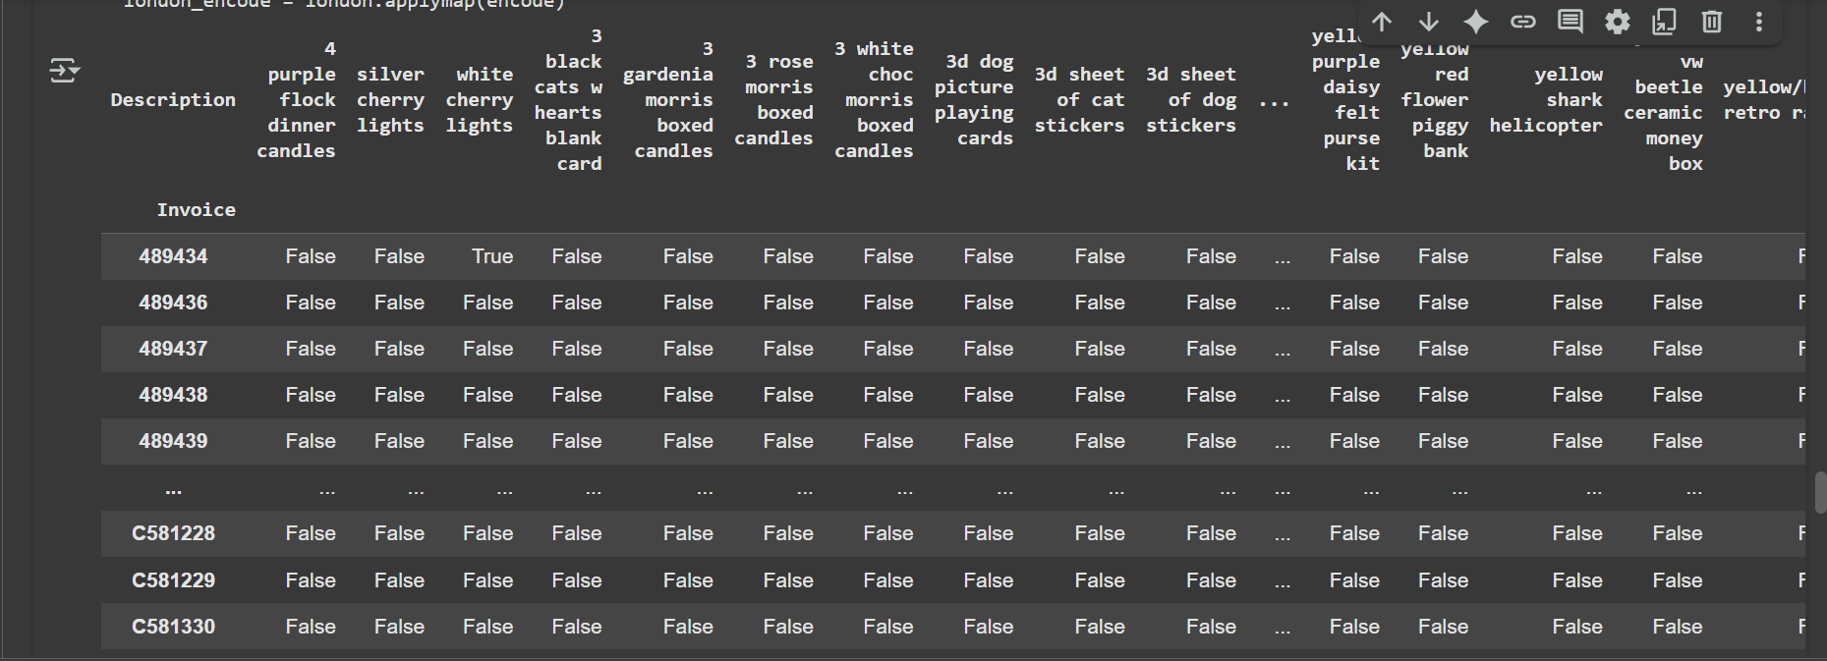

Information :

1. A function encode is defined.
2. If the value x equals 0 → return **False**.
3. For any other value (1, 2, …) → return **True**.
4. london_encode = london.applymap(encode) london is your pivot table (26,005 invoices × 1,300 products).
5. applymap() applies the encode function to **every single cell** of the DataFrame.
6. 0 → False
7. Any nonzero (like 1) → True
8. London_encode Now london_encode is the same table, but instead of integers it’s filled with **boolean values** (True/False)
9. Take transactions with more than 1 unique product

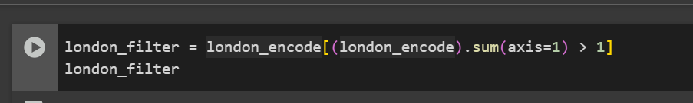

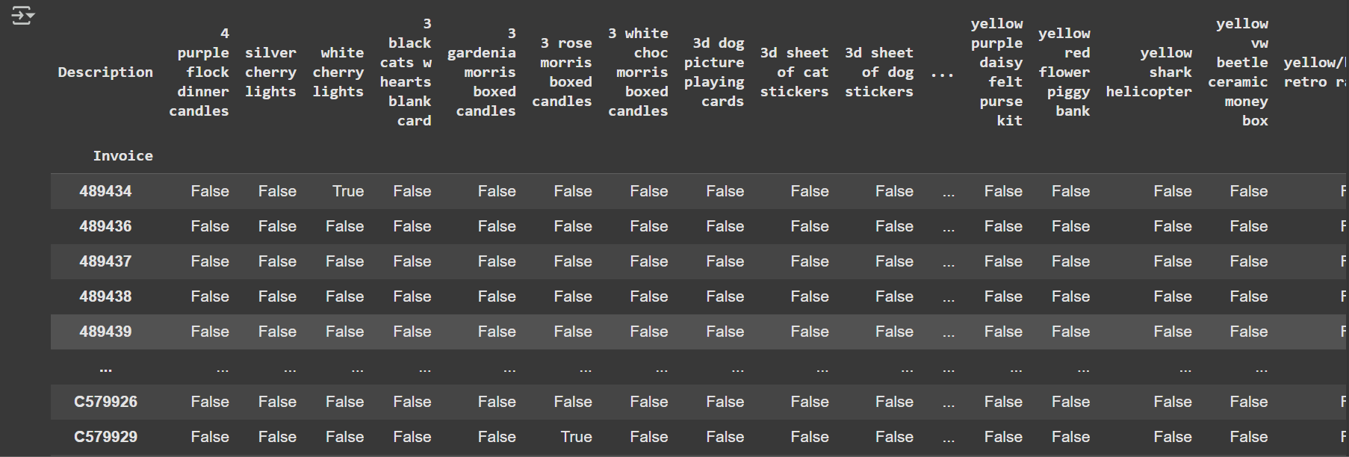

Information :

1. london_encode

* This is your boolean transaction matrix (True = bought, False = not bought).
* Each row = an invoice.
* Each column = a product.

1. london_encode.sum(axis=1)

* axis=1 means summing **across columns** (for each row/invoice).
* Since True = 1 and False = 0, this gives you the **number of products purchased** in that invoice.
* Example: Invoice with [True, False, True, False] → sum = 2.

1. > 1

* Keeps only rows where the invoice contains **more than one product**.
* Single-product invoices are removed.

1. Result (london_filter)

* A filtered DataFrame containing only invoices where customers bought **at least 2 different items**.

1. Last Analysis Project 2
2. Import Library

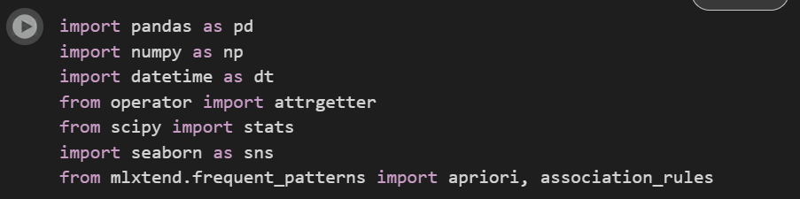

Information : This library that use in this project

1. Import CSV

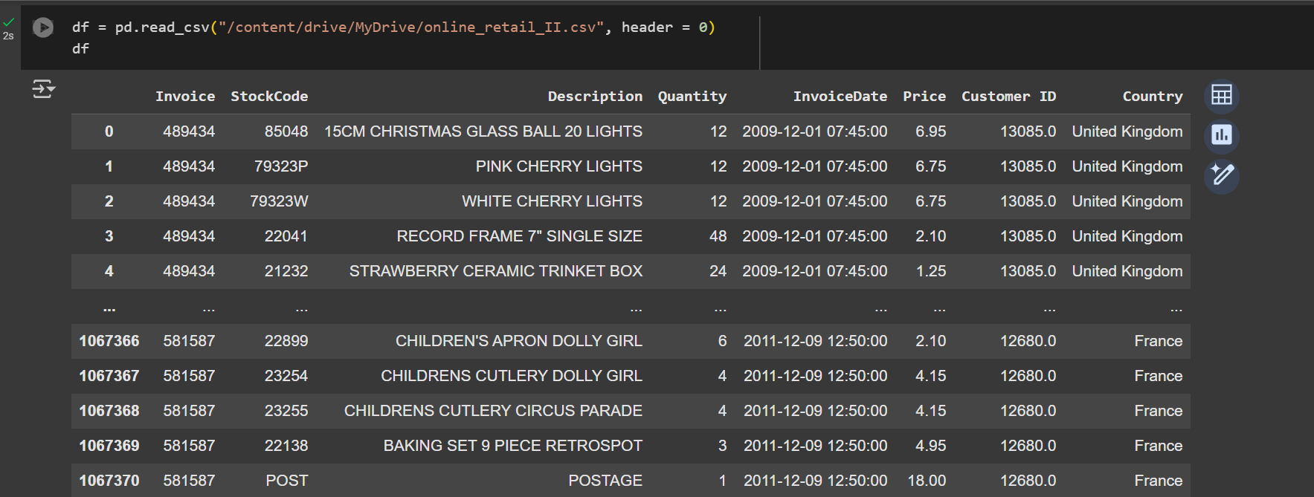

Information : This code import data from CSV and header=0 tells pandas that the first row (row index 0) in the file should be treated as the column names (headers)

1. Data Cleaning

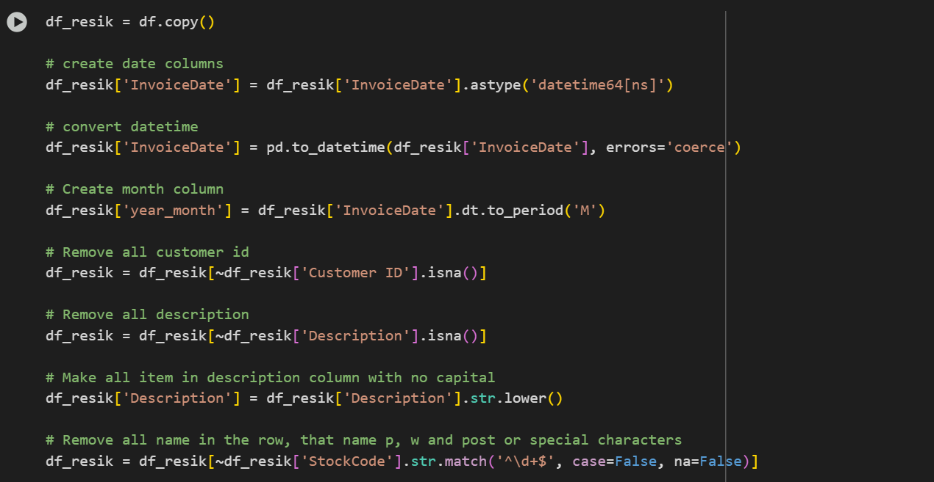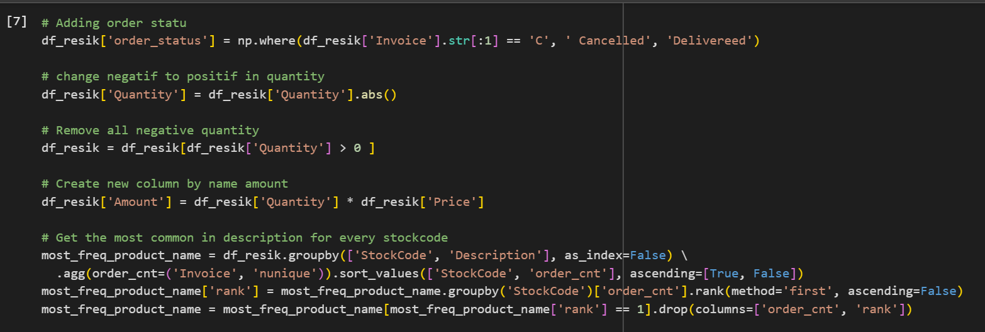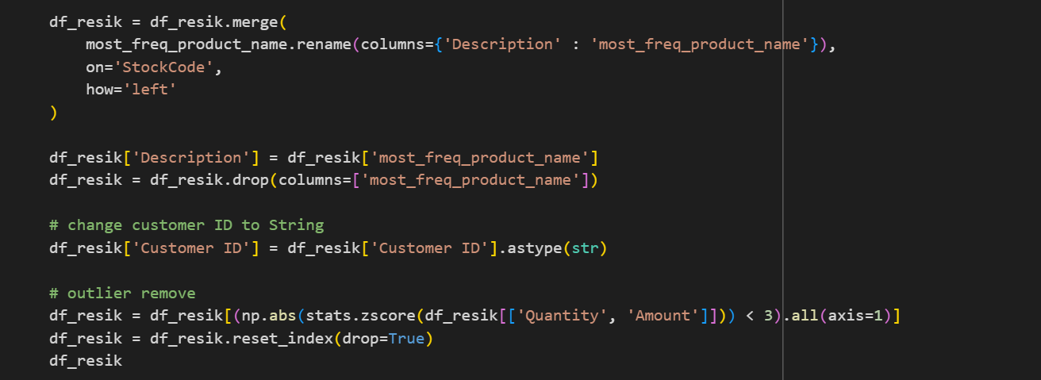

Information :

1. df_resik = df.copy() You create df_resik from the original dataset so the raw data stays untouched.
2. Convert InvoiceDate to proper datetime format. Then create a new column year_month that captures the year and month (e.g., 2011-12).
3. Remove missing values Drop rows where Customer ID is missing. Drop rows where Description (product name) is missing.
4. df_resik['Description'] All product names are converted to lowercase so “Mug” and “mug” are treated the same.
5. df_resik[~df_resik['StockCode'].str.match('^\d+$', ...)] Removes stock codes that are **only numbers** (likely non-product codes like postage, adjustments, etc.).
6. df_resik['order_status'] If the invoice number starts with “C”, mark it as **Cancelled**; otherwise mark as delivered.
7. Convert negative quantities to positive (abs()), then drop rows with zero or negative quantities (just keep valid purchases).
8. df_resik['Amount'] Adds a new column Amount = total value of that line item.
9. Find the most common product name for each StockCode

* Group by StockCode and Description.
* Count how many unique invoices each appeared in (order_cnt).
* Rank them and keep the most frequent description per stock code.

1. Replace inconsistent names

* Merge this “most frequent product name” back into the dataset.
* Replace all Descriptions with the standardized one.
* Drop the temporary helper column.

1. **Format Customer IDs** Convert Customer ID to string type.
2. df_resik = df_resik[(np.abs(stats.zscore(df_resik[['Quantity', 'Amount']])) < 3).all(axis=1)] Drops rows where Quantity or Amount are extreme outliers (z-score above 3).
3. **Reset index** Cleans up the index after filtering.
4. Info type data

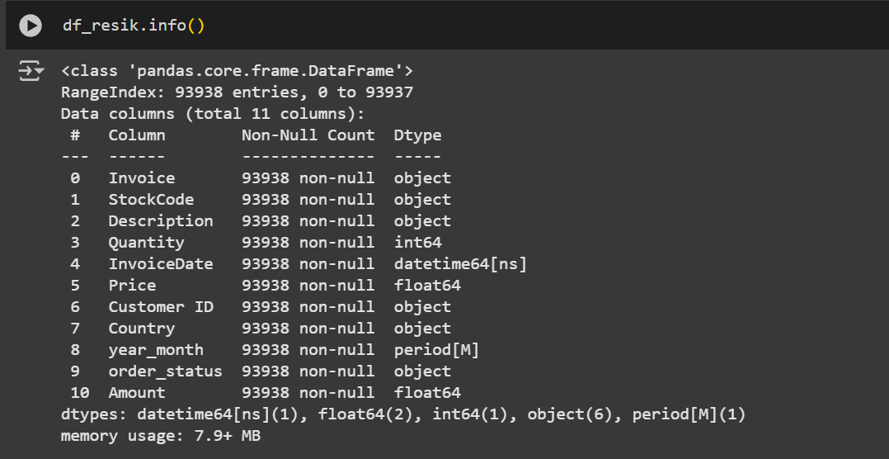

Information : This is showing about type data every column in data frame df_resik

1. Already online retail. (Create online retail dataframe)

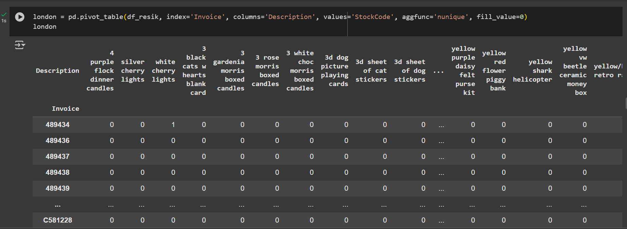



Information :

1. **index='Invoice'** → each row in the pivot table represents a unique invoice (one transaction or order).
2. **columns='Description'** → each column is a product description (e.g., "red mug", "blue chair").
3. **values='StockCode'** → you’re summarizing based on the stock codes.
4. **aggfunc='nunique'** → counts how many *unique stock codes* for that product description appear in each invoice.
5. **fill_value=0** → fills any missing values with 0 instead of leaving them empty (NaN).
6. London info type data

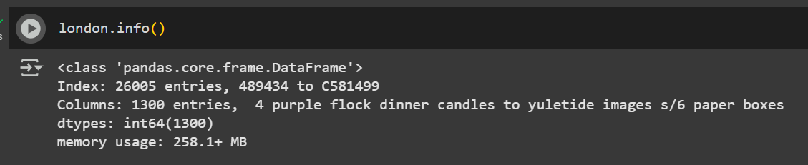

Information :

1. Encode the basket DataFrame with True for all values ​​above 0 and False for all values ​​0

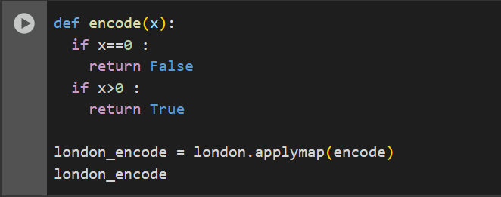

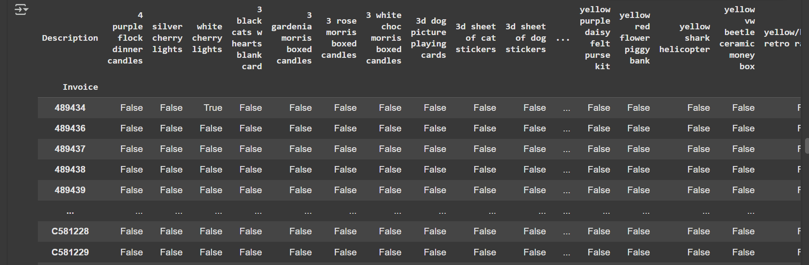

Information :

1. If the value of a cell is 0 → return False (product not bought in that invoice).
2. If the value is greater than 0 → return True (product was bought in that invoice).
3. applymap() applies the encode function to **every single cell** of the pivot table london.
4. The original london table had counts of unique stock codes.
5. After applying encode, those counts are replaced by True or False.
6. London Encode Result

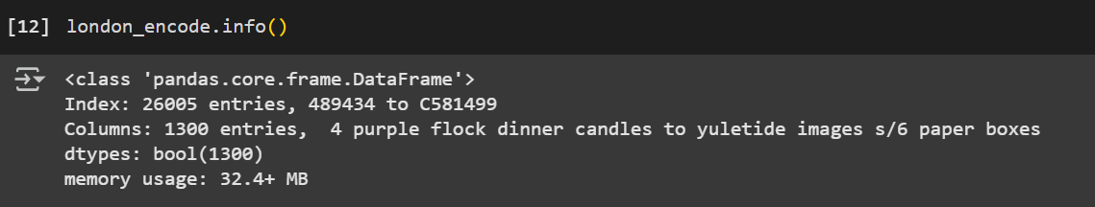

Information : this info about MB data and storage that use.

1. Take transactions with more than 1 unique product

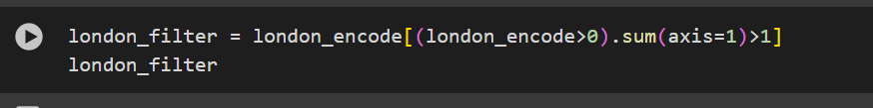

Information :

1. (london_encode > 0)

* london_encode already contains True / False.
* In Python, True is treated as 1, False as 0.
* So (london_encode > 0) is kind of redundant—it just keeps the same True/False mask

1. sum(axis=1)

* For each row (an **Invoice**), count how many True values appear across all products.
* This gives you “how many different products were bought in that invoice.”

1. > 1

* Keep only invoices where the customer bought **more than 1 distinct product**.
* If an invoice has only one product, it’s filtered out.

1. Final result (london_filter)

* A filtered version of london_encode showing only invoices that contained **at least 2 different items**.

1. London filter info

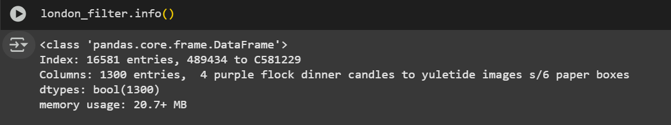

Information : This info about MB data and storage that I use.

1. Applying a priori algorithm (Create a frequent itemset list (a collection of products that are frequently purchased)

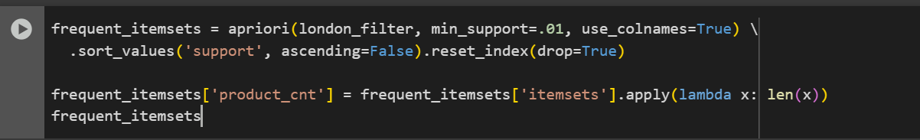

;

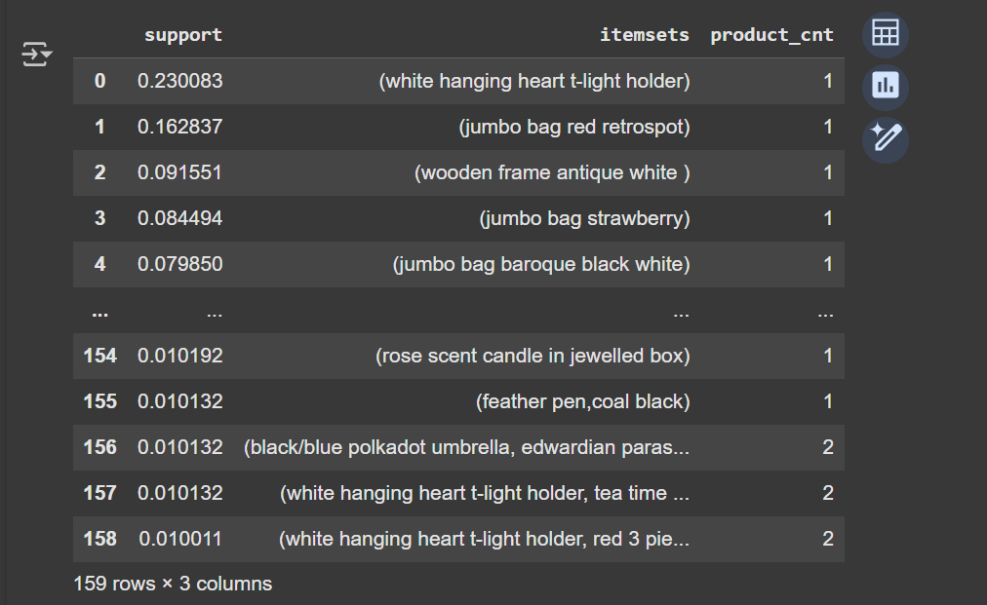

Information :

1. apriori(london_filter, min_support=.01, use_colnames=True)

* Runs the **Apriori algorithm** on your filtered invoice–product matrix.
* min_support=.01 → keep only itemsets that appear in at least **1% of all invoices**.
* use_colnames=True → output item names (not just column indices).

Output a DataFrame with columns like

* support: fraction of invoices that contain that itemset
* itemsets: the actual set of products

1. .sort_values('support', ascending=False)

* Sort itemsets by how frequently they occur.
* Top rows = most common product(s) combinations.

1. .reset_index(drop=True) Clean up the index to make it sequential after sorting.
2. frequent_itemsets['product_cnt'] = … Add a new column counting how many items are in each itemsets.
3. Relationship meaning 🌐

* **Single-item rows** (top of your table) tell you which products are most popular overall. “White hanging heart t-light holder” is in nearly a quarter of all orders.
* **Multi-item rows** (lower in your table) tell you about **co-occurrence patterns**. e.g., row 157 shows {white hanging heart t-light holder, tea time ...} with support ≈ 1%, meaning *“About 1% of all invoices include both these products together.”*
* *These* ***relationships*** *are the foundation for* ***market basket analysis****:*

1. *If two products appear together frequently, they may be complementary.*
2. *Shops could use this insight to make product bundles, cross-sell, or arrange items side by side.*
3. Calculate the support, confidence, and lift values ​​of each possible product pair

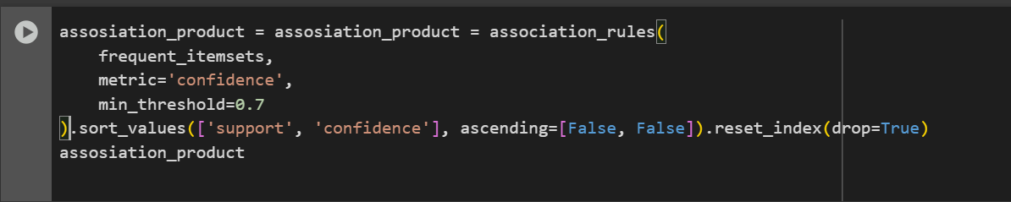

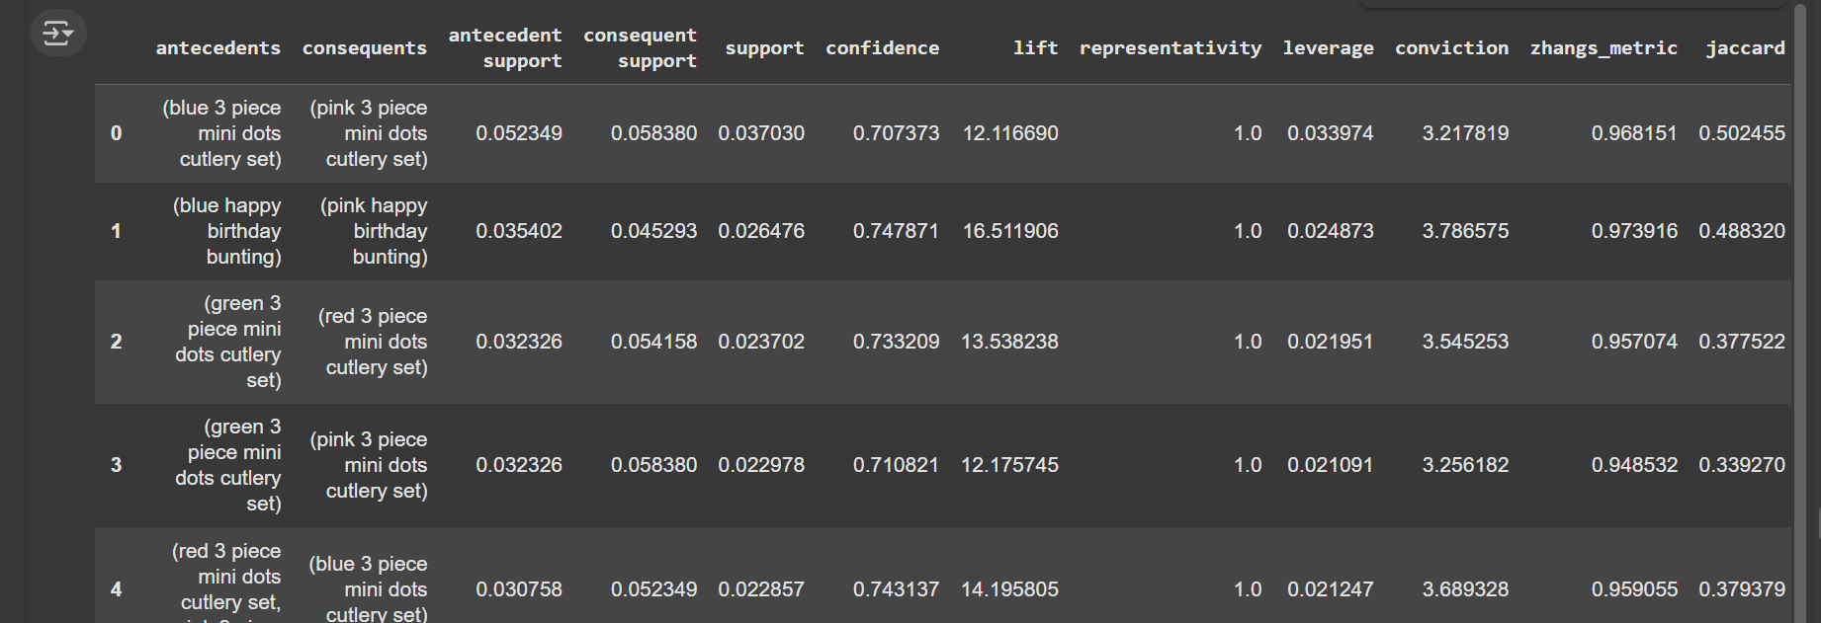

Information :

1. association_rules(...) Uses the Apriori result (frequent_itemsets) to generate rules of the form:

{antecedent}⇒{consequent}

meaning: *“If someone buys antecedent, they are likely to also buy consequent.”*

1. metric='confidence', min_threshold=0.7

* Only keeps rules where the **confidence ≥ 70%**.
* **Confidence** = how often the consequent appears, given the antecedent. Example: if 100 people buy mugs, and 75 of them also buy tea, then confidence = 75%.

1. .sort_values(['support', 'confidence'], ascending=[False, False])

* Orders results so the **most common + strongest rules** appear first.
* support = fraction of all invoices where both antecedent and consequent occur.
* confidence = strength of the conditional relationship.

1. **.reset_index(drop=True)**

* Just cleans the index after sorting

Other information :

* **antecedent support**How often the antecedent (the “if” product) appears in transactions. Example: 0.052349 → about 5.2% of all baskets contain the *blue cutlery set*.
* **consequent support** How often the consequent (the “then” product) appears in transactions.  
   Example: 0.058380 → 5.8% of baskets contain the *pink cutlery set*.
* **support** How often *both antecedent and consequent* appear together.  
   Example: 0.037030 → 3.7% of transactions had both the blue and pink cutlery set.
* **confidence**Probability that if the antecedent is bought, the consequent will also be bought.  
  Example: 0.707373 → 70.7% chance.
* **lift**How much more likely they are to be bought together compared to random chance.